Today, many types of [computers (Links to an external site.)](https://www.computerhope.com/jargon/c/computer.htm) are used in our everyday life. In most parts of the world, it's impossible to use a product or service that doesn't utilize a computer.

**Applications of Computing in Different Fields**

Below are examples of the industries, areas, and different fields using computers.

**Banks and financial**

Computers play a significant role in handling all of the world's money. Below are examples of how computers are used in the financial market and places dealing with money.

* **ATM**- When you make a withdraw from an [ATM (Links to an external site.)](https://www.computerhope.com/jargon/a/atm.htm), you are using a computer.
* **Digital currency**- When depositing money in a bank, it is stored as a digital record. A computer keeps track of how much money is in your account.
* **Trading**- Stocks and commodities are traded using computers. In fact, today there are even thousands of computers using advanced [algorithms (Links to an external site.)](https://www.computerhope.com/jargon/a/algorith.htm) that handle trading without needing humans.

**Business**

Business is another big sector for computers and most money earned and spent is done using a computer. Below are some of the examples of how computers are used in business.

* **Registe**r - If the business deals with selling goods to a consumer (e.g., a grocery store), a cash register, which is a computer, is used to complete transactions.
* **Workers computer**- Many businesses assign each employee a computer that allows them to produce work and solve problems for the company.
* **Server**- If the business uses computers, connects to the Internet, or handles e-mail and files, a [server (Links to an external site.)](https://www.computerhope.com/jargon/s/server.htm) is used to help manage everything.

**Communication**

 Today's communication around the world is almost all digital and handled by computers. Below are examples of how computers are used in the communication industry.

* Smartphone - If you have a [smartphone (Links to an external site.)](https://www.computerhope.com/jargon/s/smartphone.htm), you have a computer in your pocket.
* **E-mail**- More electronic mail ([e-mail (Links to an external site.)](https://www.computerhope.com/jargon/e/email.htm)) is sent today than postal mail ([snail mail (Links to an external site.)](https://www.computerhope.com/jargon/s/snaimail.htm)), and computers handle all creation and distribution of that e-mail.
* **VoIP**- All voice over IP communication ([VoIP (Links to an external site.)](https://www.computerhope.com/jargon/v/voip.htm)) is handled and done by computers.
* **Computer-assisted speech**- Those who are disabled or cannot speak can use a computer to help them communicate. For example, [Stephen Hawking (Links to an external site.)](https://www.computerhope.com/people/stephen_hawking.htm) uses a computer to communicated.
* **Voice recognition -** Any phone or another system that uses [voice recognition  (Links to an external site.)](https://www.computerhope.com/jargon/v/voicreco.htm)is using a computer to translate what is heard into text or other data that can be understood by the computer.

**Defense and military**

Many technologies (e.g., GPS and the Internet) were initially created or started with a defense-related purpose. Today, computers are still an important aspect of the defense industry.

* **Encryption**- Secure communication is vital in the defense industry and computers are used to [encrypt  (Links to an external site.)](https://www.computerhope.com/jargon/e/encrypt.htm)communications that should remain secret.
* **GPS**- Using computers with [GPS (Links to an external site.)](https://www.computerhope.com/jargon/g/gps.htm)allows the military to track people and equipment and is still used today.
* **Computer-aided flight -** Many of today's jets and other aircraft require computers to fly and operate.
* **Drones -** A drone is either autonomous or remotely driven and uses computers to operate.

**Education**

As computers evolve, so does how computers are used in the education field. Below is a list of how a computer can be used in education.

**Internet -** Connecting a student to the Internet gives him or her access to an endless supply of knowledge. As mentioned later, the Internet would not be possible without computers.

* **Learning**- Computers can also be used to help design and create a more visual learning experience for students. Using [electronic whiteboards (Links to an external site.)](https://www.computerhope.com/jargon/e/elecwb.htm) with computers can also benefit a student by giving them a more hands-on experience.
* **Writing**- Although reports can still be done using pen, pencil, or even a typewriter, a computer makes it much easier to write, format, save, share, and print reports.
* **Keep records**- Computers are used to track students scores, identify struggling students, and are used to create a final report.
* **Testing**- Computers can assist students and teachers with the testing process by stepping the student through a series of questions and keep track of the results.

**Internet**

Without computers, the [Internet (Links to an external site.)](https://www.computerhope.com/jargon/i/internet.htm) would not exist. Below are a few examples of computers are used to help run the Internet.

* **DNS**- When you type in a [URL (Links to an external site.)](https://www.computerhope.com/jargon/u/url.htm) like https://www.computerhope.com/, a [DNS (Links to an external site.)](https://www.computerhope.com/jargon/d/dns.htm) must translate it into an [IP address (Links to an external site.)](https://www.computerhope.com/jargon/i/ip.htm), which helps your computer to communicate with the server.****
* **Web server**- Every web page requires a [web server (Links to an external site.)](https://www.computerhope.com/jargon/w/webserve.htm) or computer capable of receiving and sending requests when someone wants to view a web page.
* **Programs**- A computer is also needed to run [scripts (Links to an external site.)](https://www.computerhope.com/jargon/s/script.htm) and [programs (Links to an external site.)](https://www.computerhope.com/jargon/p/program.htm). For example, a [search engine (Links to an external site.)](https://www.computerhope.com/jargon/s/searengi.htm), [shopping cart (Links to an external site.)](https://www.computerhope.com/jargon/s/shopcart.htm), or [forum (Links to an external site.)](https://www.computerhope.com/jargon/f/forum.htm) are all examples of programs that need a computer.
* **Services**- Other services like e-mail, [FTP (Links to an external site.)](https://www.computerhope.com/jargon/f/ftp.htm), and [SSH (Links to an external site.)](https://www.computerhope.com/jargon/s/ssh.htm) also require a computer or are [daemons (Links to an external site.)](https://www.computerhope.com/jargon/d/daemon.htm) on the web server.

**Medical**

The medical field is another place where computers are vital and used every day. Below are some examples of how computers help those in the medical field.

* **Medical records**- More and more medical records are being digitally stored. Storing these files digitally allow for quick access and transfer of medical information so doctors can know your history.
* **Monitoring**- Computers help with monitoring a patient and can alert staff in the case of an emergency.
* **Research**- A lot of the medical research that is done today is computer assisted. Without the assistance of a computer, it would either not be possible or take so much longer that it wouldn't be viable.
* **Diagnosis**- Computers can assist in the diagnosis of a patient, from gathering a patient's history and conditions to comparing that information against a database of existing information.
* **Surgery**- Although most surgery is still done with humans, it is becoming more practical and accessible for computer robot-assisted surgery. After being programmed, these robots can make surgery more accurate, faster, and less prone to human errors.

**Transportation**

Computers also play an important part in transportation. Below are a few examples of how computers help the transportation field.

* **Cars**- Most may not realize it, but all modern cars today have multiple computers that help control and manage the vehicle.
* **Traffic lights**- The traffic lights that help control traffic are all run by computers.
* **GPS**- Cars that include a [GPS (Links to an external site.)](https://www.computerhope.com/jargon/g/gps.htm) mapping system have computers for display and calculating routes.
* **Airplanes**- The airplanes that help transport millions of people and goods every year are filled with computers that help control the plane.
* **Public transportation**- Train, bus, subway, and all forms of public transportation are highly dependent on computers to manage traffic flow, monitor operation, and handle payments.
* **Self-driving cars**- Although relatively new, self-driving cars are becoming increasingly popular and rely on a computer to make all decisions on how to drive.

**Multimedia**

Computers also play a significant role in video and audio. Below are examples of how computers are used in the film and audio industry.

* **Editing**- Once a movie, video, song, or audio track is created a computer can edit that media instead of having to manually make cuts to the film or audio track.
* **CGI**- Computer [animation (Links to an external site.)](https://www.computerhope.com/jargon/a/animatio.htm) and [CGI (Links to an external site.)](https://www.computerhope.com/jargon/c/cgi.htm) has become a norm in big budget films. To create these effects computers and sometimes [server farms (Links to an external site.)](https://www.computerhope.com/jargon/s/servfarm.htm) are used.
* **Manipulation**- Computers can be used to manipulate pictures, video, and audio. For example, someone could use [Adobe Photoshop (Links to an external site.)](https://www.computerhope.com/adobe.htm) to add or remove elements from an image.
* **Recording and playback**- Computers can also be used to assist in the recording of audio tracks and then selectively playback each audio track.
* **Creation**- Computers can also be used to help in creating new multimedia content. For example, creating 3D animation, 3D model, or a techno audio track can be done on a computer. After creating a 3D model, a [3D printer (Links to an external site.)](https://www.computerhope.com/jargon/num/3d-printer.htm) could also be used to build a product.
* **TV, DVD, media players**- Today's [Smart TVs (Links to an external site.)](https://www.computerhope.com/jargon/s/smart-tv.htm), [DVD (Links to an external site.)](https://www.computerhope.com/jargon/d/dvd.htm) players, [DVRs (Links to an external site.)](https://www.computerhope.com/jargon/d/dvr.htm), etc., contain simple computing circuitry to connect the device to the Internet, run apps, and more.

**Robotics**

The industry of [robotics (Links to an external site.)](https://www.computerhope.com/jargon/r/robot.htm) is exploding and computers once again play an important role in controlling robots. Below are some examples of how computers help control robotic machinery.

* **Control**- Computers are what help control robotics. For example, without a computer, an assembly robotic arm would not know where to place a part, what speed to operate, or if a problem has occurred.
* **Learning**- Computers can take the input given by a robot and take that information to help learn and adapt to new conditions.

**Simulations**

Some problems are so complex that it would be impossible for humans to calculate or would take too long to calculate. Computers are used to help solve these complex problems in a timely fashion.

* **Weather prediction**- Earth has an extremely complex weather system, and computers are used to gather all of the variables and create weather reports.
* **Product simulations**- Before some products go into development, computers simulate how they would work in the real world. By creating a simulation, a company or government agency can make adjustments before the product goes into development.
* **Big data simulation**- With cheap [data storage (Links to an external site.)](https://www.computerhope.com/jargon/s/stordevi.htm) companies can now store a massive amount of data. With this [big data (Links to an external site.)](https://www.computerhope.com/jargon/b/bigdata.htm), a computer can be used to fjust ind unknown patterns.

In today's world, we use computers for all our tasks. Our day-to-day activities: paying bills, buying groceries, using social media, seeking entertainment, working from home, communicating with a friend, etc., can all be done using a computer. So it is important not only to know how to use a computer, but also to understand the components of a computer and what they do.

This topic explains all concepts related to computer in detail, from origin to end. The idea of computer literacy is also discussed, which includes the definition and functions of a computer. You learn about the components of a computer, the concept of hardware and software, representation of data/information, the concept of data processing and applications

### **What is a Computer?**

A **computer** is an electronic device that accepts data from the user, processes it, produces results, displays them to the users, and stores the results for future usage.

**Data** is a collection of unorganized facts & figures and does not provide any further information regarding patterns, context, etc. Hence data means "unstructured facts and figures".

**Information** is a structured data i.e. organized meaningful and processed data. To process the data and convert into information, a computer is used.

**Characteristics of a Computer**

1. It is a **machine**.

The computer needs human intervention to operate.

1. It is **electronic.**

The computer is made up of electronic components and is run by electricity.

1. It is **automatic.**

The computer can perform a set of instructions uninterruptedly once instructed.

1. It can **manipulate data.**

The computer can come up with an output given an input data.

1. It has **memory.**

The computer can store and retrieve information.

1. It has **logical functions.**

The computer is capable of performing not only mathematical operations but logical operations as well.

**Capabilities of a Computer**

**1. Speed**

Computers can process data at a very high speed.

**2. Accuracy**

Computers process the data prepared by the users. That is, if the input is wrong, the output will be wrong also.

**3. Repetitiveness**

Computers can work continuously and repetitively.

**4. Storage**

Computers can store and retrieve relatively large amount of data.

**5. Programmable**

Computers can take a series of instructions and automatically execute each instructions one after another.

**Classifications of Computer**

**A.  According to Purpose**

**General – Purpose Computers**. Capable of dealing with a variety of problems.

**Special – Purpose Computers**. Designed to perform a specific task, with limited capabilities, and the program of instructions is build into the machine.

#### **B.  According to Data Handled**

**Analog Computers**. Deal with continuously changing physical data

Such as pressure, temperature ( or data that can be measure ).

They are used for scientific, engineering and process – control purposes – operations which result to approximated values.

**Digital Computers**. Work with values that are in a discrete from (or Data that can be counted).

They are use for business applications, and also scientific operations, and are ideal  when 100% accuracy is desired, thus resulting to data exact in values.

**Hybrid Computers**. Incorporate in a single machine the capabilities of the analog and digital computers.

They are used in space vehicle simulations and training of astronauts.

##### **C.   According to Capacity**

Capacity refers to :

* + Amount of data that can be stored in memory
  + Speed of internal operation of the computer
  + Capacity of storage devices
  + Number and types of peripheral devices

**Microcomputers**

Small computers which are portable. Uses microprocessor (the CPU on a chip), ROM and RAM. It sometimes known as a “Single-Chip Processor” or a “System-on-a-Chip”. Examples: Desktop and floor standing units, luggable, laptops, notebooks, subnotebooks, pocket PCs, and pen computers.

**Minicomputers**

Machine which are in the middle of microcomputers and mainframes in terms of cost and capability. These act as “servers” which are connected to several workstations or terminals.

**Mainframe**

The oldest category, these are air-cooled computers bigger in sizes, about the size of a jeep. They are used mostly by banks, airlines, and insurance companies that handles millions of transactions.

**Supercomputers**

The biggest and fastest computers. They can perform 50 million instructions per second and are used in applications such as nuclear weapon development and accurate weather forecasting. In addition, it is used to process very large amounts of information including processing information to predict hurricanes, to generate satellite images and navigation points, and to process military war scenarios

In today's world, we use computers for all our tasks. Our day-to-day activities: paying bills, buying groceries, using social media, seeking entertainment, working from home, communicating with a friend, etc., can all be done using a computer. So it is important not only to know how to use a computer, but also to understand the components of a computer and what they do.

This topic explains all concepts related to computer in detail, from origin to end. The idea of computer literacy is also discussed, which includes the definition and functions of a computer. You learn about the components of a computer, the concept of hardware and software, representation of data/information, the concept of data processing and applications

### **Pre-Modern Era**

**Manual-Mechanical Device**

These are devices powered by hand and requires physical effort from the user. Examples:

**Abacus**. The first man-made computing device that uses beads; invented in China.

**Napier’s bones**. An arrangement of bones wherein numbers are printed; invented by John Napier.

**Oughtred’s Slide Rule**. Consists of movable bars with a precise scale which uses approximations for solving problems; invented by William Oughtred.

**Pascaline**. The first mechanical calculator ( adding machine ) that uses cogged wheels;invented by Blaise Pascal.

**Leibnitz Calculator**. The improved Pascaline which could multiply and divide; invented by Gottfried Leibnitz.

**Babbage’s  Difference and Analytical Engines**. These engines embodied most of the design of modern computers. The Difference Engine which can compute tables and the Analytical engine which is completely  automatic and capable of calculating any mathematical problems; invented by Charles Babbage.

## ****Electro-mechanical Devices****

## These are devices powered by an electronic motor and use switches and relays. Examples:

**Holllerith’s Punch Card Machine**. The first use of punched cards to store data; developed by Herman Hollerith.

**Automatic Weaving Loom**. Uses the concept of punched card to control his looms; by Joseph Marie Jacquard.

**Automatic Sequence Controlled Calculator (MARK I).** The first genera-purpose computer; invented by Howard Aiken.

**Electronic Devices**. These are devices which use only electrical switches and circuitry                         instead of mechanical relays. Their principal components are circuit boards, transistors or                silicon chips:

   Examples:

**ABC (Atanasoff – Berry Computer).** The first special-purpose digital computer that solves simultaneous equations; developed by John Atanasoff.

**Electronic Numerical Integrator and Calculator (ENIAC).** The first fully electronic general-purpose digital computer ever completed by John Eckert and John Mauchly.

**Electronic Discrete Variable Computer(EDVAC).** The completely internally programmed machine. This is simply the enhancement of ENIAC to overcome its limitations.

**Electronic Delayed Storage Automatic Computer (EDSAC).** Also known as Electronic Binary Digital computer that uses binary representation of data and  internally stored program; developed by John Eckert and John Presper.

**First Generation Computers ( 1951 – 1958 )**

**Major Hardware Features:** Vacuum tubes and magnetic drums

**Processing Speed**: 1,000 instructions per second

**Size:** Mainframes only

**Examples:**

Universal Automatic Computer (UNIVAC I ) – the first commercial business computer, developed by John Eckert and John Mauchly.

IBM 701 – the first generation computer of IBM

IBM 650 – the most popular generation compute

**Second Generation Computers ( 1959 – 1963 )**

**Major Hardware Features:**  Transistors and magnetic core

**Processing Speed:**1,000,000 instructions per second

**Size:**  Mainframes only

**Examples:**

                                 TRADIC – first  transistorized computer

                                 UNIVAC II

                                 IBM 7070,7090 AND 1400 series

**Third Generation Computers ( 1964 – 1971 )**

**Major Hardware Features:** Integrated circuits or “chips”

**Processing Speed:** 10,000,000 instructions per second

**Size:** Mainframes only

**Examples:**

                                   IBM System 360 – the most significant 3rd generation

                                                                 Computer

                                   Burroughs B5500

**Fourth Generation Computers ( 1971 – 1979 )**

                    Major Hardware Features: Microprocessors or Large – second IC

                    Processing Speed: 100,000,000 instructions per second

                    Sized: Mainframes, Minicomputers, and Microcomputers

**Examples:**

                             Apple II; TRS 80

                             IBM System 360, System 3090

                             IBM PC – XT base computers

                             IBM PC – AT base computers

                            Motorolla 68030 based computers

**Fifth Generation Computers ( 1980-present)**

**Major Hardware Features:** Circuitry based on gallium arsenide

**Processing Speed**: 10 to 15 million instructions per second and more

**Size**: Large Computers

## ****Evolution of Personal Computer****

**Personal Computer (PC)**– are Integrated Circuit that contains the Arithmetic Logic Unit (ALU) and Control Unit  of computer Central Processing Unit.

These were created for a limited number of people.

**Microprocessor** – a single Central Processing Unit (CPU). This determine the types of speed rating expressed in megahertz (MHz) or millions of cycle per second. The rating of power of megahertz is directly proportional to the speed of the processor. Thus, this is given the task of determining the computer power of the system and is considered the brain of the computer.

1. Developmental Stage (1974-1977) Example: MITS Altair
2. Early Adopter Stage (1977-1981) Example: Early Apple II Model
3. Corporate Stage (1981-1984) Example: IBM PC
4. Integrated System Stage (1984-1987) Example: Apple Macintosh, IBM AT
5. Networked System Stage (1987-1990) Example: IBM AT, AT & T, Unix
6. Information Age Stage (1990-present) Example: Compuphone, Laptops.

**DEVELOPMENT OF PERSONAL COMPUTERS**

**First Generation of the Microcomputers**

* 4004 by Intel in 1971 – the first microprocessor in the world.

- a 4-bit microprocessor, can transfer 4 bits of information at a time.

- the microprocessor is composed of several units and those units communicate with each other and with the outside word by a group of 4 binary paths (called bus), each bit can transmit one bit at a time.

**Second Generations of the Microcomputers**

* + 8008 by Intel in 1972 -        the first commercial 8 bit microprocessor

it transferred information 8 bits at a time

considered the foremost “first generation” 8 bits processor calculator like architecture

* + 8080 in 1973          - enhanced 8008, 2nd generation version of 8008

- it has more addressing and I/O capability, more instructions and executes instructions faster.

* + 8085 in 1976          - most enhance version of 8080

         - 8 bit microprocessor

 - added features as power on reset, vectored interrupts, serial I/O port and a +5 volts.

                INTEL Major Competitors and the code of their microprocessor

* + - Zilog Z80
    - Motorola 6800
    - Commodore 6

**Third Generations of the Microcomputers**

* + 8086 by Intel 1978 – 16 bit microprocessor was 10 times faster than the most enhanced 8-bit microprocessor.
  + 8088 by Intel in 1979 – which is internally 16-bit and externally 8-bit compatible

     - it the choice of IBM in producing the PC, PC XT

* + 80186 by Intel in 1982 – (and a companion with 80188) which packs the processing power of 8086 plus support with 15 other chips
  + 80286 by Intel in 1982 – the microprocessor that controls the IBM PC

      - an enhanced 80186 that provides special features necessary for memory management and protection.

* + Pentium – 32 bits version of microprocessor.

# How are computers used?

Today, many types of [computers](https://www.computerhope.com/jargon/c/computer.htm) are used in our everyday life. In most parts of the world, it's impossible to use a product or service that doesn't utilize a computer. Below are examples of the industries, areas, and different fields using computers.

## Bank ATMBanks and financial

Computers play a significant role in handling all of the world's money. Below are examples of how computers are used in the financial market and places dealing with money.

* **ATM**- When you make a withdraw from an [ATM](https://www.computerhope.com/jargon/a/atm.htm), you are using a computer.
* **Digital currency** - When depositing money in a bank, it is stored as a digital record. A computer keeps track of how much money is in your account.
* **Trading**- Stocks and commodities are traded using computers. In fact, today there are even thousands of computers using advanced [algorithms](https://www.computerhope.com/jargon/a/algorith.htm) that handle trading without needing humans.

## Business

Business is another big sector for computers and most money earned and spent is done using a computer. Below are some of the examples of how computers are used in business.

* **Registe**r - If the business deals with selling goods to a consumer (e.g., a grocery store), a cash register, which is a computer, is used to complete transactions.
* **Workers computer** - Many businesses assign each employee a computer that allows them to produce work and solve problems for the company.
* **Server** - If the business uses computers, connects to the Internet, or handles e-mail and files, a [server](https://www.computerhope.com/jargon/s/server.htm) is used to help manage everything.

## HyperX Cloud headset with microphoneCommunication

Today's communication around the world is almost all digital and handled by computers. Below are examples of how computers are used in the communication industry.

* Smartphone - If you have a [smartphone](https://www.computerhope.com/jargon/s/smartphone.htm), you have a computer in your pocket.
* **E-mail** - More electronic mail ([e-mail](https://www.computerhope.com/jargon/e/email.htm)) is sent today than postal mail ([snail mail](https://www.computerhope.com/jargon/s/snaimail.htm)), and computers handle all creation and distribution of that e-mail.
* **VoIP**- All voice over IP communication ([VoIP](https://www.computerhope.com/jargon/v/voip.htm)) is handled and done by computers.
* **Computer-assisted speech** - Those who are disabled or cannot speak can use a computer to help them communicate. For example, [Stephen Hawking](https://www.computerhope.com/people/stephen_hawking.htm) uses a computer to communicated.
* **Voice recognition -** Any phone or another system that uses [voice recognition](https://www.computerhope.com/jargon/v/voicreco.htm) is using a computer to translate what is heard into text or other data that can be understood by the computer.

## Defense and military

Many technologies (e.g., GPS and the Internet) were initially created or started with a defense-related purpose. Today, computers are still an important aspect of the defense industry.

* **Encryption**- Secure communication is vital in the defense industry and computers are used to [encrypt](https://www.computerhope.com/jargon/e/encrypt.htm) communications that should remain secret.
* **GPS**- Using computers with [GPS](https://www.computerhope.com/jargon/g/gps.htm) allows the military to track people and equipment and is still used today.
* **Computer-aided flight -** Many of today's jets and other aircraft require computers to fly and operate.
* **Drones -** A drone is either autonomous or remotely driven and uses computers to operate.

## Education

As computers evolve, so does how computers are used in the education field. Below is a list of how a computer can be used in education.

* **Internet -** Connecting a student to the Internet gives him or her access to an endless supply of knowledge. As mentioned later, the Internet would not be possible without computers.
* **Learning** - Computers can also be used to help design and create a more visual learning experience for students. Using [electronic whiteboards](https://www.computerhope.com/jargon/e/elecwb.htm) with computers can also benefit a student by giving them a more hands-on experience.
* **Writing** - Although reports can still be done using pen, pencil, or even a typewriter, a computer makes it much easier to write, format, save, share, and print reports.
* **Keep records** - Computers are used to track students scores, identify struggling students, and are used to create a final report.
* **Testing** - Computers can assist students and teachers with the testing process by stepping the student through a series of questions and keep track of the results.

## Internet

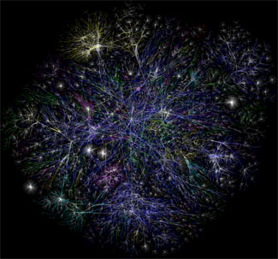Without computers, the [Internet](https://www.computerhope.com/jargon/i/internet.htm) would not exist. Below are a few examples of computers are used to help run the Internet.

* **DNS** - When you type in a [URL](https://www.computerhope.com/jargon/u/url.htm) like https://www.computerhope.com/, a [DNS](https://www.computerhope.com/jargon/d/dns.htm) must translate it into an [IP address](https://www.computerhope.com/jargon/i/ip.htm), which helps your computer to communicate with the server.
* **Web server** - Every web page requires a [web server](https://www.computerhope.com/jargon/w/webserve.htm) or computer capable of receiving and sending requests when someone wants to view a web page.
* **Programs** - A computer is also needed to run [scripts](https://www.computerhope.com/jargon/s/script.htm) and [programs](https://www.computerhope.com/jargon/p/program.htm). For example, a [search engine](https://www.computerhope.com/jargon/s/searengi.htm), [shopping cart](https://www.computerhope.com/jargon/s/shopcart.htm), or [forum](https://www.computerhope.com/jargon/f/forum.htm) are all examples of programs that need a computer.
* **Services** - Other services like e-mail, [FTP](https://www.computerhope.com/jargon/f/ftp.htm), and [SSH](https://www.computerhope.com/jargon/s/ssh.htm) also require a computer or are [daemons](https://www.computerhope.com/jargon/d/daemon.htm) on the web server.

## Medical

The medical field is another place where computers are vital and used every day. Below are some examples of how computers help those in the medical field.

* **Medical records** - More and more medical records are being digitally stored. Storing these files digitally allow for quick access and transfer of medical information so doctors can know your history.
* **Monitoring** - Computers help with monitoring a patient and can alert staff in the case of an emergency.
* **Research** - A lot of the medical research that is done today is computer assisted. Without the assistance of a computer, it would either not be possible or take so much longer that it wouldn't be viable.
* **Diagnosis** - Computers can assist in the diagnosis of a patient, from gathering a patient's history and conditions to comparing that information against a database of existing information.
* **Surgery** - Although most surgery is still done with humans, it is becoming more practical and accessible for computer robot-assisted surgery. After being programmed, these robots can make surgery more accurate, faster, and less prone to human errors.

## Transportation

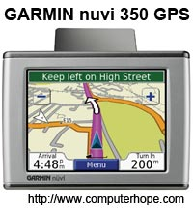

Computers also play an important part in transportation. Below are a few examples of how computers help the transportation field.

* **Cars** - Most may not realize it, but all modern cars today have multiple computers that help control and manage the vehicle.
* **Traffic lights** - The traffic lights that help control traffic are all run by computers.
* **GPS** - Cars that include a [GPS](https://www.computerhope.com/jargon/g/gps.htm) mapping system have computers for display and calculating routes.
* **Airplanes** - The airplanes that help transport millions of people and goods every year are filled with computers that help control the plane.
* **Public transportation** - Train, bus, subway, and all forms of public transportation are highly dependent on computers to manage traffic flow, monitor operation, and handle payments.
* **Self-driving cars** - Although relatively new, self-driving cars are becoming increasingly popular and rely on a computer to make all decisions on how to drive.

## Multimedia

Computers also play a significant role in video and audio. Below are examples of how computers are used in the film and audio industry.

* **Editing** - Once a movie, video, song, or audio track is created a computer can edit that media instead of having to manually make cuts to the film or audio track.
* **CGI** - Computer [animation](https://www.computerhope.com/jargon/a/animatio.htm) and [CGI](https://www.computerhope.com/jargon/c/cgi.htm) has become a norm in big budget films. To create these effects computers and sometimes [server farms](https://www.computerhope.com/jargon/s/servfarm.htm) are used.
* **Manipulation** - Computers can be used to manipulate pictures, video, and audio. For example, someone could use [Adobe Photoshop](https://www.computerhope.com/adobe.htm) to add or remove elements from an image.
* **Recording and playback** - Computers can also be used to assist in the recording of audio tracks and then selectively playback each audio track.
* **Creation** - Computers can also be used to help in creating new multimedia content. For example, creating 3D animation, 3D model, or a techno audio track can be done on a computer. After creating a 3D model, a [3D printer](https://www.computerhope.com/jargon/num/3d-printer.htm) could also be used to build a product.
* 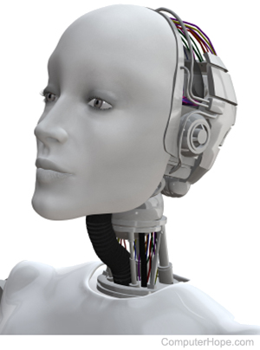**TV, DVD, media players** - Today's [Smart TVs](https://www.computerhope.com/jargon/s/smart-tv.htm), [DVD](https://www.computerhope.com/jargon/d/dvd.htm) players, [DVRs](https://www.computerhope.com/jargon/d/dvr.htm), etc., contain simple computing circuitry to connect the device to the Internet, run apps, and more.

## Robotics

The industry of [robotics](https://www.computerhope.com/jargon/r/robot.htm) is exploding and computers once again play an important role in controlling robots. Below are some examples of how computers help control robotic machinery.

* **Control** - Computers are what help control robotics. For example, without a computer, an assembly robotic arm would not know where to place a part, what speed to operate, or if a problem has occurred.
* **Learning** - Computers can take the input given by a robot and take that information to help learn and adapt to new conditions.

## Simulations

Some problems are so complex that it would be impossible for humans to calculate or would take too long to calculate. Computers are used to help solve these complex problems in a timely fashion.

* **Weather prediction** - Earth has an extremely complex weather system, and computers are used to gather all of the variables and create weather reports.
* **Product simulations** - Before some products go into development, computers simulate how they would work in the real world. By creating a simulation, a company or government agency can make adjustments before the product goes into development.
* **Big data simulation** - With cheap [data storage](https://www.computerhope.com/jargon/s/stordevi.htm) companies can now store a massive amount of data. With this [big data](https://www.computerhope.com/jargon/b/bigdata.htm), a computer can be used to find unknown patterns.

# Why should I learn about computers?

Updated: 03/06/2020 by Computer Hope

Today, many people all over the world use some form of a computer every day. Having a general understanding of computers can help you function in today's world, and it can prevent you from getting left behind. Below we've created a list of reasons why you should learn more about computers with additional resources on how you can learn more about computers.

**Tip**

Many people believe [smartphones](https://www.computerhope.com/jargon/s/smartphone.htm), [tablets](https://www.computerhope.com/jargon/t/tablet.htm), and other computing devices are not computers. However, this confusion is another reason why you should learn more about computers, so you can realize all of these devices are a form of computer.

## Computers help you work faster

As computers, [software](https://www.computerhope.com/jargon/s/software.htm), and [hardware](https://www.computerhope.com/jargon/h/hardware.htm) improve, so do their capabilities. For example, someone with even a very basic understanding of a [word processor](https://www.computerhope.com/jargon/w/word-processor.htm) can work faster and enjoy writing more than someone typing on a [typewriter](https://www.computerhope.com/jargon/t/typewriter.htm). With a word processor, you can easily edit anywhere in a document, erase text, move text, copy text, change fonts, and much more. All these things were impossible or tough to do with a typewriter.

Also, after learning the basics of a task or program, you can continue to learn and evolve until you become a master and become even faster at working. For example, someone familiar with a program and knows its [keyboard shortcuts](https://www.computerhope.com/jargon/k/keyboard-shortcut.htm) can be two to three times faster than someone with a basic understanding of a program.

## Computers can answer almost any question

Today, a person with a computer connected to the [Internet](https://www.computerhope.com/jargon/i/internet.htm) can find answers to virtually any question. Understanding the computer, connecting to the Internet, opening a [browser](https://www.computerhope.com/jargon/b/browser.htm), and using a [search engine](https://www.computerhope.com/jargon/s/searengi.htm), gives a person so much more capabilities than someone without this knowledge.

* [How to connect to the Internet.](https://www.computerhope.com/issues/ch000720.htm)
* [How to find information on the Internet.](https://www.computerhope.com/issues/ch000082.htm)

## A computer can teach you almost anything

Computers may be utilized to answer virtually any question and teach you how to do almost anything. Lots of people have visited [YouTube](https://www.computerhope.com/jargon/y/youtube.htm) and other websites to become proficient at a skill to get a better job.

## Understanding computer terminology helps with other technology

Having a good understanding of the terminology and lingo used with computers can help you be more efficient with other technology. For example, anyone who has connected to the Internet has a better understanding of using the Internet and connecting other devices.

## Reduces the change of being tricked or scammed

Someone more familiar with how computers work is less likely to be tricked, scammed, or infected by [viruses](https://www.computerhope.com/jargon/v/virus.htm). For example, a person familiar with e-mail [attachments](https://www.computerhope.com/jargon/a/attachme.htm) and their potential dangers is less likely to open a malicious e-mail attachment.

## Resolve problems and questions faster

A person with a basic understanding of computers and software is going to have an easier time solving problems they may have encountered. For example, someone with experience who gets an [error](https://www.computerhope.com/jargon/e/error.htm) while logging into an account may realize its because the [caps lock key](https://www.computerhope.com/jargon/c/capslock.htm) is enabled, and passwords are [case sensitive](https://www.computerhope.com/jargon/c/casesens.htm).

## Computers and robots are replacing jobs

More and more computers and [robots](https://www.computerhope.com/jargon/r/robot.htm) are assisting or replacing jobs that were done in the past by humans. If you have a better understanding of how to use computers, you can help program these machines, know how to fix them, and work more efficiently with them. If you lack the technological skills, it's more likely you would be one of the first people in your company to be replaced.

* [What jobs are being taken over by robots and computers?](https://www.computerhope.com/issues/ch001799.htm)

## Learning about computers can help you find a job

Almost every job today and jobs of the future require some technical knowledge. Learning more about computers and computer software required for the job can a competitive edge against others who may be applying for the same job.

* [What jobs are available in the computer industry?](https://www.computerhope.com/issues/ch000764.htm)

## Computers can save and make you money

A computer can also save you money, and there are several places online that allow you to compare prices and shop. Someone with the right skills can quickly find the best price and even get the item shipped to them without even having to leave their house.

A computer can also make you money by giving you the freedom of working for yourself by doing different things online.

**COMPUTER CONCEPTS**

The word “computer” comes from the term to compute, meaning to calculate. It is one word that is commonly used today. The use of computer has a great effect on all aspects of human life.

**DEFINITION OF COMPUTER**

**Computer** - an electronic data processing device designed to accept and manipulate data and instructions.

* it is machine that can store, move, add, subtract, edit and evaluate data.

**Characteristics of a Computer**

1. It is a machine.

The computer needs human intervention to operate.

1. It is electronic.

The computer is made up of electronic components and is run by electricity.

1. It is automatic.

The computer can perform a set of instructions uninterruptedly once instructed.

1. It can manipulate data.

The computer can come up with an output given an input data.

1. It has memory.

The computer can store and retrieve information.

1. It has logical functions.

The computer is capable of performing not only mathematical operations but logical operations as well.

**Capabilities of a Computer**

1. Speed.

Computers can process data at a very high speed.

1. Accuracy.

Computers process the data prepared by the users. That is, if the input is wrong, the output will be wrong also.

1. Repetitiveness.

Computers can work continuously and repetitively.

1. Storage.

Computers can store and retrieve relatively large amount of data.

1. Programmable.

Computers can take a series of instructions and automatically execute each instructions one after another.

**Limitations of a Computer**

1. Computers cannot operate without a set of instructions.
2. Computers cannot derive a meaning from objects.
3. Computers cannot correct errors, it can only detect them.
4. Computers are subject to occasional breakdown.
5. Computers cannot run without electric power.

**Classifications of Computer**

## According to Purpose

1. **General – Purpose Computers**. Capable of dealing with a variety of problems.
2. **Special – Purpose Computers**. Designed to perform a specific task, with limited capabilities, and the program of instructions is build into the machine.

#### According to Data Handled

* 1. **Analog Computers**. Deal with continuously changing physical data

Such as pressure, temperature ( or data that can be measure ). They are used for scientific, engineering and process – control purposes – operations which result to approximated values.

* 1. **Digital Computers**. Work with values that are in a discrete from (or

Data that can be counted). They are use for business applications, and also scientific operations, and are ideal when 100% accuracy is desired, thus resulting to data exact in values.

* 1. **Hybrid Computers**. Incorporate in a single machine the capabilities of the analog and digital computers. They are used in space vehicle simulations and training of astronauts.

##### According to Capacity

Capacity refers to :

* Amount of data that can be stored in memory
* Speed of internal operation of the computer
* Capacity of storage devices
* Number and types of peripheral devices

1. **Microcomputers.** Small computers which are portable. Uses microprocessor (the CPU on a chip), ROM and RAM. It sometimes known as a “Single-Chip Processor” or a “System-on-a-Chip”. Examples: Desktop and floor standing units, luggable, laptops, notebooks, subnotebooks, pocket PCs, and pen computers.
2. **Minicomputers**. Machine which are in the middle of microcomputers and mainframes in terms of cost and capability. These act as “servers” which are connected to several workstations or terminals.
3. **Mainframe.** The oldest category, these are air-cooled computers bigger in sizes, about the size of a jeep. They are used mostly by banks, airlines, and insurance companies that handles millions of transactions.
4. **Supercomputers**. The biggest and fastest computers. They can perform 50 million instructions per second and are used in applications such as nuclear weapon development and accurate weather forecasting. In addition, it is used to process very large amounts of information including processing information to predict hurricanes, to generate satellite images and navigation points, and to process military war scenarios

# EVOLUTION OF COMPUTERS

## Pre-Modern Era

* **Manual-Mechanical Device**. These are devices powered by hand and requires physical effort from the user. Examples:

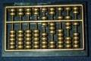

**Abacus**. The first man-made computing device that uses beads; invented in China.

**Napier’s bones**. An arrangement of bones wherein numbers are printed; invented by John Napier.

**Oughtred’s Slide Rule**. Consists of movable bars with a precise scale which uses approximations for solving problems; invented by William Oughtred.

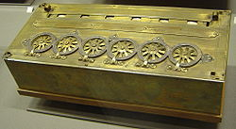

**Pascaline**. The first mechanical calculator ( adding machine ) that uses cogged wheels;invented by Blaise Pascal.

**Leibnitz Calculator**. The improved Pascaline which could multiply and divide; invented by Gottfried Leibnitz.

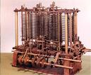**Babbage’s Difference and Analytical Engines**. These engines embodied most of the design of modern computers. The Difference Engine which can compute tables and the Analytical engine which is completely automatic and capable of calculating any mathematical problems; invented by Charles Babbage.

* 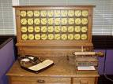**Electro-mechanical Devices**. These are devices powered by an electronic motor and use switches and relays. Examples:

**Holllerith’s Punch Card Machine**. The first use of punched cards to store data; developed by Herman Hollerith.

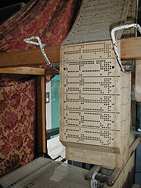**Automatic Weaving Loom**. Uses the concept of punched card to control his looms; by Joseph Marie Jacquard.

**Automatic Sequence Controlled Calculator (MARK I).** The first genera-purpose computer; invented by Howard Aiken.

* **Electronic Devices**. These are devices which use only electrical switches and circuitry instead of mechanical relays. Their principal components are circuit boards, transistors or silicon chips: Examples:

**ABC (Atanasoff – Berry Computer).** The first special-purpose digital computer that solves simultaneous equations; developed by John Atanasoff.

**Electronic Numerical Integrator and Calculator (ENIAC).** The first fully electronic general-purpose digital computer ever completed by John Eckert and John Mauchly.

**Electronic Discrete Variable Computer(EDVAC).** The completely internally programmed machine. This is simply the enhancement of ENIAC to overcome its limitations.

**Electronic Delayed Storage Automatic Computer (EDSAC).** Also known as Electronic Binary Digital computer that uses binary representation of data and internally stored program; developed by John Eckert and John Presper.

1. **First Generation Computers ( 1951 – 1958 )**

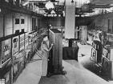

**Major Hardware Features:** Vacuum tubes and magnetic drums

**Processing Speed**: 1,000 instructions per second

**Size:** Mainframes only

**Examples:**

Universal Automatic Computer (UNIVAC I ) – the first commercial business computer, developed by John Eckert and John Mauchly.

IBM 701 – the first generation computer of IBM

IBM 650 – the most popular generation compute

1. **Second Generation Computers ( 1959 – 1963 )**

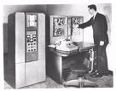

**Major Hardware Features:** Transistors and magnetic core

**Processing Speed:** 1,000,000 instructions per second

**Size:** Mainframes only

**Examples:**

TRADIC – first transistorized computer

UNIVAC II

IBM 7070,7090 AND 1400 series

1. **Third Generation Computers ( 1964 – 1971 )**

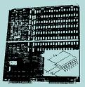

**Major Hardware Features:** Integrated circuits or “chips”

**Processing Speed:** 10,000,000 instructions per second

**Size:** Mainframes only

**Examples:**

IBM System 360 – the most significant 3rd generation

Computer

Burroughs B5500

1. **Fourth Generation Computers ( 1971 – 1979 )**

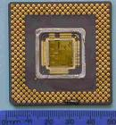

Major Hardware Features: Microprocessors or Large – second IC

Processing Speed: 100,000,000 instructions per second

Sized: Mainframes, Minicomputers, and Microcomputers

**Examples:**

Apple II; TRS 80

IBM System 360, System 3090

IBM PC – XT base computers

IBM PC – AT base computers

Motorolla 68030 based computers

1. **Fifth Generation Computers ( 1980-present)**



**Major Hardware Features:** Circuitry based on gallium arsenide

**Processing Speed**: 10 to 15 million instructions per second and more

**Size**: Large Computers

**EVOLUTION OF PERSONAL COMPUTER**

**Personal Computer (PC)** – are Integrated Circuit that contains the Arithmetic Logic Unit (ALU) and Control Unit of computer Central Processing Unit.

* + - These were created for a limited number of people.

**Microprocessor** – a single Central Processing Unit (CPU). This determine the types of speed rating expressed in megahertz (MHz) or millions of cycle per second. The rating of power of megahertz is directly proportional to the speed of the processor. Thus, this is given the task of determining the computer power of the system and is considered the brain of the computer.

A. Developmental Stage (1974-1977) Example: MITS Altair

B. Early Adopter Stage (1977-1981) Example: Early Apple II Model

C. Corporate Stage (1981-1984) Example: IBM PC

D. Integrated System Stage (1984-1987) Example: Apple Macintosh, IBM AT

E. Networked System Stage (1987-1990) Example: IBM AT, AT & T, Unix

F. Information Age Stage (1990-present) Example: Compuphone, Laptops.

**DEVELOPMENT OF PERSONAL COMPUTERS**

**First Generation of the Microcomputers**

* 4004 by Intel in 1971 – the first microprocessor in the world.

- a 4-bit microprocessor, can transfer 4 bits of information at a time.

- the microprocessor is composed of several units and those units communicate with each other and with the outside word by a group of 4 binary paths (called bus), each bit can transmit one bit at a time.

**Second Generations of the Microcomputers**

* 8008 by Intel in 1972 - the first commercial 8 bit microprocessor

it transferred information 8 bits at a time

considered the foremost “first generation” 8 bits processor calculator like architecture

* 8080 in 1973 - enhanced 8008, 2nd generation version of 8008

- it has more addressing and I/O capability, more instructions and executes instructions faster.

* 8085 in 1976 - most enhance version of 8080

- 8 bit microprocessor

- added features as power on reset, vectored interrupts, serial I/O port and a +5 volts.

INTEL Major Competitors and the code of their microprocessor

* Zilog Z80
* Motorola 6800
* Commodore 6

**Third Generations of the Microcomputers**

* 8086 by Intel 1978 – 16 bit microprocessor was 10 times faster than the most enhanced 8-bit microprocessor.
* 8088 by Intel in 1979 – which is internally 16-bit and externally 8-bit compatible

- it the choice of IBM in producing the PC, PC XT

* 80186 by Intel in 1982 – (and a companion with 80188) which packs the processing power of 8086 plus support with 15 other chips
* 80286 by Intel in 1982 – the microprocessor that controls the IBM PC

- an enhanced 80186 that provides special features necessary for memory management and protection.

* Pentium – 32 bits version of microprocessor.

**EVOLUTION OF PERSONAL COMPUTER**

**Personal Computer (PC)** – are Integrated Circuit that contains the Arithmetic Logic Unit (ALU) and Control Unit of computer Central Processing Unit.

* + - These were created for a limited number of people.

**Microprocessor** – a single Central Processing Unit (CPU). This determine the types of speed rating expressed in megahertz (MHz) or millions of cycle per second. The rating of power of megahertz is directly proportional to the speed of the processor. Thus, this is given the task of determining the computer power of the system and is considered the brain of the computer.

A. Developmental Stage (1974-1977) Example: MITS Altair

B. Early Adopter Stage (1977-1981) Example: Early Apple II Model

C. Corporate Stage (1981-1984) Example: IBM PC

D. Integrated System Stage (1984-1987) Example: Apple Macintosh, IBM AT

E. Networked System Stage (1987-1990) Example: IBM AT, AT & T, Unix

F. Information Age Stage (1990-present) Example: Compuphone, Laptops.

**DEVELOPMENT OF PERSONAL COMPUTERS**

**First Generation of the Microcomputers**

* 4004 by Intel in 1971 – the first microprocessor in the world.

- a 4-bit microprocessor, can transfer 4 bits of information at a time.

- the microprocessor is composed of several units and those units communicate with each other and with the outside word by a group of 4 binary paths (called bus), each bit can transmit one bit at a time.

**Second Generations of the Microcomputers**

* 8008 by Intel in 1972 - the first commercial 8 bit microprocessor

it transferred information 8 bits at a time

considered the foremost “first generation” 8 bits processor

calculator like architecture

* 8080 in 1973 - enhanced 8008, 2nd generation version of 8008

- it has more addressing and I/O capability, more instructions and executes instructions faster.

* 8085 in 1976 - most enhance version of 8080

- 8 bit microprocessor

- added features as power on reset, vectored interrupts, serial I/O port and a +5 volts.

INTEL Major Competitors and the code of their microprocessor

* Zilog Z80
* Motorola 6800
* Commodore 6502

**Third Generations of the Microcomputers**

* 8086 by Intel 1978 – 16 bit microprocessor was 10 times faster than the most enhanced 8-bit microprocessor.
* 8088 by Intel in 1979 – which is internally 16-bit and externally 8-bit compatible

- it the choice of IBM in producing the PC, PC XT

* 80186 by Intel in 1982 – (and a companion with 80188) which packs the processing power of 8086 plus support with 15 other chips
* 80286 by Intel in 1982 – the microprocessor that controls the IBM PC

- an enhanced 80186 that provides special features necessary for memory management and protection.

* Pentium – 32 bits version of microprocessor.

###### COMPONENTS OF COMPUTER SYSTEMS

**System** is an organized group of related and interdependent elements, parts, or components interacting in performing the individual and specific tasks for the purpose of meeting one or more goals and objectives.

1. Hardware – refers to the internal and external compositions of the computer.

2. Software – refers to a set of instructions that is to be executed by computers called program.

3. Peopleware – refers to the personnel involved.

4. Dataware – refers to the steps specifying the manner certain activities are to be accomplished.

**HARDWARE:**

* + - is the physical components of the computer system whether internal or external that are tangible in nature.

**The components of the internal hardware (organization) are:**

* + - * CPU
      * Memory
      * I/O

**And the external hardware (peripherals) are categories into:**

* Input hardware
* Processing hardware
* Storage hardware
* Output hardware
* Communication hardware

**Components of the Internal hardware:**

1. **Central Processing Unit (CPU)**. This is known as the processor. It is the brain of the computer who does the actual work of executing the instructions in the program.

**Parts of the CPU:**

* **Control Unit (CU).** Interprets program instructions and directs the other parts of the CPU, and communicates with the external input/output devices and secondary storage media.
* **Arithmetic Logic Unit (ALU).** It does all the calculations, comparisons or logical operations on data, as directed by the Control Unit.

**Other parts that go along with the Processor:**

* **Bus.** It is an electronic circuit that sends data and messages between the other components.
* **Ports**. It attach input and output devices to the computer.
* **Expansion slots**. It allow the addition of extra features.
* **Registers.** Are special temporary storage which quickly accepts, stores, and transfers data and instructions for immediate use.

1. **Memory Unit**. It stores data and instructions before the execution and the processed data as well.

**Types of Memory:**

* **Internal Memory**
  + **Random-Access Memory (RAM)** – refers to as Main Memory or Primary Memory. It is a volatile type of memory which stores data and instructions that have been input and are waiting to be processed, stores the results of processing until they are released to the output devices.
  + **Read-Only Memory (ROM)** – contains permanently stored instructions that cannot be changed.
* **External Memory**

**Secondary Memory**. Also known as Auxiliary Memory. It is a non-volatile type of memory that is responsible foe keeping files permanently.

1. **Input and Output Unit** – it allows communication between the computer and its outside world via input and output devices.

**External Hardware/Peripherals**

**Categories of External Hardware**

1. **Input Hardware** – it accept or collect data and convert it into a form suitable for processing.

**Types:**

* 1. **Keyboard- Entry Devices include the following:**

1. **Keyboards**. It is the most commonly used input device. It is similar to a standard (QWERT) typewriter with some additional keys.
2. **Terminals.** It consists of keyboard, video display screen and a communication line to a mainframe computer.

**3 types:**

* + - **Dumb** – can be used only to input data to and receive information from a computer system. Ex. Systems in airport ticket and check-n counters.
    - **Smart** – can do input and output and has some limited processing capability. It may be able to edit or verify data before it is sent to a larger computer. Ex. ATM, ETM (Electronic Ticket Machine) and POS (Point-of-Sales)
    - **Intelligent** – a full fledge microcomputer with a communication link. It is a stand-alone device with its own input, output, processing and storage capacity, and its own software. Ex. Executive workstation.
  1. **Direct-Entry Devices include the following:**
     + 1. Pointing Devices
          - **Mouse** – a pointing device that allows you to control an on-screen cursor.
          - **Trackball** – the upside-down version of the mouse. A ball mounted in box is rolled with the fingers to move the cursor.
          - **Joystick** – a video display screen that picks up input from the user through the touch of a finger.
          - **Light pen** –it is a point and draw input device that allows you to draw directly on screen.
          - **Digitizing tablet** – a pen-like device with which the user “sketches” an image or puck
          - **Pen based systems** – a pen like stylus to enter handwriting and marks into a computer.
       2. **Scanning Device.**  It translates images of text, drawing, and photos and the like into forms of data that can be understood by the computer.
* **Bar code readers** – photoelectric scanner that translate the bar code symbols into digital forms.
* **Mark and Character recognitions devices:**

**MICR (Magnetic-Ink Character Recognition)** – it reads the strange-looking numbers printed at the bottom of bank checks or treasury bills.

**OMR (Optical Mark Recognition)** – it reads pencil marks and converts them into computer-usable form.

**OCR(Optical Character Recognition)** – it reads special preprinted characters and converts them into machine-readable form.

**Fax Machine (Facsimile Transmission Machine)** – it scans an image and sends it as an electronic signals over telephone lines to a receiving fax machine, which recreates the image on paper.

**Imaging Systems/Image Scanner/ Graphics Scanner** – it converts text, drawings, and photographs into forms that can be stored in a computer system and then manipulated.

**Smart Cards and Optical cards**

**Smart cards –** it contain a microprocessor and a memory chip.

**Optical Cards** – it s a plastic, laser-recordable card used with an optical card reader.

* + - 1. **Other Devices**

**Voice Recognition Systems** – they convert human speech into digital code.

**Audio- Input Device** – they record or play analog sounds and translates them into digital forms

**Video- Input Devices** – signals that come from VCR o r a camera recorder are converted to digital form through a special video card installed to the computer.

**Electronic cameras** – they capture images in electronic form for immediate viewing on a television or monitor of a computer

**Sensors** – it collects specific kinds of data directly from the environment and transmits it to the computer.

1. **Processing Hardware**.  It is used to retrieve and execute the instructions provided by the computer

**Main Components:**

* CPU
* Main Memory

**System Unit** –it contains electrical components that make the computer works.

* + **Power supply** – is a device that converts AC to DC power to run the computer.
  + **Motherboard** – it is the main circuit board in the system unit.
  + **CPU** – the microprocessor chip.
  + **Specialized Processor chips** – used to speed up your computer system
  + **System clock** – it controls how fast all operations within a computer are performed.
  + **RAM chips** - chips that temporarily hold data and instructions that will be needed shortly by the CPU.
  + **ROM chips** – chips containing programs that are built into the computer at the factory.
  + **Cache memory** – is the special high-speed memory that the CPU can access quickly.
  + **Expansion slots and boards-** are sockets on the motherboard into which you can plug expansion cards or boards.
  + **Bus line** – the electrical pathways through which nits are transmitted within the CPU and between the CPU and other devices in the system unit.
  + **Port** – the sockets on the outside of the system unit that each connected to an expansion board on the inside of the system unit.
  + **PCMICIA slots and cards** – it represents a new bus standard for notebooks, subnotebooks and pocket computers.

1. **Storage Hardware**. It temporarily or permanently store data used for processing and the output of such processing.

**Two types:**

* 1. **Primary Storage** – refers to main memory (RAM),which is volatile.
  2. **Secondary Storage**- refers to storage devices that retain data and instruction in a relatively permanent (non-volatile) form.
* **Diskettes**
* **Hard disks**
* **Optical storage** – use a laser beam to pack information densely on are movable disk
* **Magnetic tapes** – a sequential file storage represented by various arrangements of magnetized spots along the width of the tape
* **Magnetic disk** – a metal plotter where data is represented by magnetized spots on the tracks.
* **Magnetic strip** – a recording of a data cell device capable of storing 400 million of data
* **Paper tape** – a continuous strip of paper wound on a reel where data is represented by holes punched on the paper.
* **Drum** – a recording medium of data represented by magnetized spots that is coated with a magnetically sensitive material divided into tracks.
* **Continuous forms** – a long sheets of paper where data is represented thru print out.
* **Computer Output Microfilm (COM)-** stores large volume of information printed or photographed as a very small images on sheets or roll of film called Microfiche.

1. **Output Hardware**. It provide a means for the user to view information produced by the computer system.

**Two forms:**

* 1. **Hardcopy** – it is when an information has been recorded in a tangible medium, such as paper or microfilm
  2. **Softcopy** – it is when an output is temporarily displayed on the screen

**Hardcopy Output Hardware:**

* **Printer** – it is capable of printing characters, symbols and graphics.

**Categories:**

* + - 1. **Impact printer** – it has contact with papers like daisy wheel printers,dot-matrix printers and line printers
      2. **Non-impact printers** –it has no contact with the paper like laser printer, ink-jet printers and thermal printers.
* **Plotter** – they are specialized output devices that can produce high quality graphics in a variety of colors.

**3 types:**

* 1. **Pen plotter** – the most popular type of plotter
  2. **Electrostatic plotter** – electrostatic charges create tiny dots on specially treated paper.
  3. **Thermal plotter** – its pins are electronically heated and are used with heat-sensitive paper to produce images.

**Softcopy Output Hardware:**

* **Cathode Ray Tube (CRT)** – the most popular softcopy output device used on microcomputers
* **Flat Panel Displays** – they are used with portable computers.
  1. **Communication Hardware**, It facilitate the connection between computers connected with a network of computers over phone lines and other channels.

**Includes:**

* + - **Modems**  - it converts digital signals to analog signals.
    - **Cable** – commonly used when computers are wired in a circuit network, to facilitate the communication between those computers.
    - **Fax modems** – a modem with fax capability installed as a circuit board in the motherboard of a computer
    - **Multiplexers** – it combines several low-speed transmission into one high-speed transmission.
    - **Concentrator**- just like multiplexer but it collects data in a temporary storage area, then send it forward when enough has been accumulated.
    - **Front-end Processor**- the most sophisticated ,a computer that handles communications for mainframes.

**SOFTWARE:**

- is the non-physical components of the computer that are intangible in nature.

**Categories of Software:**

1. **System Software** – refers to the programs that assists in the computer operations in general thereby facilitating of applications programs.

**Types of System software:**

* + **Operating Systems** – refers to a group of related programs that supervise the execution of an application program.
  + **Operating Environment**- refers to programs that sit on top of OS.
  + **Utilities** – a single term for all types of programming aids.
  + **Programming languages** – the programs used to write other programs
  + **Language processor** – known as translators, used to convert source program into a form suitable for execution
    - **Compilers** – it translates programs written in high-level languages into machine instructions understandable by the computer**.**
    - **Assemblers** – it translate the source program written in Assembly language
    - **Interpreters** – it performs each instructions immediately after translation.

1. **Application Software** – user programs designed to solve problems such as those use in business, engineering and scientific research

**Types of Application software:**

* **Package programs** – commonly called ‘application package’ which are useful to several users.

**Types of Package programs:**

* + **Word processing software** – it allows inserting, deleting, storing m restoring and printing of documents. Ex. MS Word, Wordstar, Wordperfect
  + **Desktop Publishing software** – combines hardware and software to enable the user to combine text and images on the same page in a professional, publishable format for printing. Ex. Pagemaker, Adobe
  + **Spreadsheet Software** – allows the user to create worksheets/tables of data for financial analysis. Ex. MS Excel, Lotus 123,Quato, Visicalc
  + **Database Management System (DBMS)** – also known as database manager, consists of programs used for maintaining a database or a pool of data. Ex. Foxbase, dBase IV, MS Access, Oracle
  + **Graphics Software** – allows the user to make reports and other presentations using graphs and freedom drawings. Ex. Paintbrush, Newsmaster,Printshop, MS Paint, Powerpoint.
  + **Communication Software** – allows the user to access software and data from and to a computer at a remote location.Ex. Global chat, Freetel, PCTalk, PC Dial, Ms Netmeeting.
  + **Integrated Software** – it allows the user to create spreadsheets, databases, graphics and communication software. Ex. MS Office, Perfect, Office,Smart suite.
  + **Groupware** – it is used on networks of computer users working together on the same projects. Ex. Lotus notes, MS Works
  + **Software Suites** – combination ofspreadsheet, word processor, graphics, communications and groupware in one software. Ex. MS Office, SmartSuite, Perfect Office.
  + **Desktop Accessories** – serve as organizer of collected, small programs. Ex. Sidekick, electronic tools as calendar, clock, card file, calculator and notepad.
  + **PIM (Personal Information Manager)** –it helps organize personal information such as addresses and telephone numbers. Ex. MS Outlook
  + **Project Management Software** – used to monitor large –scale projects using this software prior to manufacturing. Ex. Orcad, Supervision, AutoCAD
  + **Multimedia Software** - allows the use of text, graphics, animation, video and sound. Ex. Multimedia toolbox, Autorware, Multimedia Works.
    - **Custom Programs** – specifically written for an organization or a single user using any programming language. Ex. Accounting system, Enrolment System, Grading system

**Levels of Programming Languages:**

1. **Machine Language** - language that the computer could directly understand. It uses symbols (string of 1’s and 0’s) to represent data and information’s.
2. **Symbolic Language** – language that uses abbreviated instructions called mnemonics.
3. **High-level Language** – language that is directly understandable to the human being, It uses decimal representation for numbers.

**PEOPLEWARE:**

– refers to the personnel involved in data processing operations.

**Functional Areas of Peopleware:**

* Systems Programming
* System analysts
* Application programming
* Computer Operations

**Personnel:**

* Data Entry Operator
* Computer Operator
* Computer Programmer
* System Analysts
* Computer Center Director
* Database Administrator

**DATAWARE or PROCEDURE**:

– refers to rules and policies that govern the operations of the whole computer system.

**Examples of Dataware:**

* Instruction Manuals
* Operating Procedures
* Processing Procedures
* Recipe Cooking

|  |  |
| --- | --- |
| **Operation** | **Description** |
|  | Take Input | The process of entering data and instructions into the computer system. |
|  | Store Data | Saving data and instructions so that they are available for processing as and when required. |
|  | Processing Data | Performing arithmetic, and logical operations on data in order to convert them into useful information. |
|  | Output Information | The process of producing useful information or results for the user, such as a printed report or visual display. |
|  | Control the workflow | Directs the manner and sequence in which all of the above operations are performed. |

## Input output and storage devices. Keyboard, Mouse, Joystick, Scanner, Web camera & Microphone, Monitor, Printer, Speaker, Headphone & Projector and USB flash drive, Memory card, DVD, CD,Hard disk, Flo

## Input Unit

This unit contains devices with the help of which we enter data into the computer. This unit creates a link between the user and the computer. The input devices translate the information into a form understandable by the computer.

## Output Unit

The output unit consists of devices with the help of which we get the information from the computer. This unit is a link between the computer and the users. Output devices translate the computer's output into a form understandable by the users.

## CPU (Central Processing Unit)

CPU is considered as the brain of the computer. CPU performs all types of data processing operations. It stores data, intermediate results, and instructions (program). It controls the operation of all parts of the computer.

CPU itself has the following three components −

* ALU (Arithmetic Logic Unit)
* Memory Unit
* Control Unit

Central Processing Unit (CPU) consists of the following features −

* CPU is considered as the brain of the computer.
* CPU performs all types of data processing operations.
* It stores data, intermediate results, and instructions (program).
* It controls the operation of all parts of the computer.

## Memory or Storage Unit

This unit can store instructions, data, and intermediate results. This unit supplies information to other units of the computer when needed. It is also known as internal storage unit or the main memory or the primary storage or Random Access Memory (RAM).

Its size affects speed, power, and capability. Primary memory and secondary memory are two types of memories in the computer. Functions of the memory unit are −

* It stores all the data and the instructions required for processing.
* It stores intermediate results of processing.
* It stores the final results of processing before these results are released to an output device.
* All inputs and outputs are transmitted through the main memory.

## Control Unit

This unit controls the operations of all parts of the computer but does not carry out any actual data processing operations.

Functions of this unit are −

* It is responsible for controlling the transfer of data and instructions among other units of a computer.
* It manages and coordinates all the units of the computer.
* It obtains the instructions from the memory, interprets them, and directs the operation of the computer.
* It communicates with Input/Output devices for transfer of data or results from storage.
* It does not process or store data.

## ALU (Arithmetic Logic Unit)

This unit consists of two subsections namely,

* Arithmetic Section
* Logic Section

### **Arithmetic Section**

Function of arithmetic section is to perform arithmetic operations like addition, subtraction, multiplication, and division. All complex operations are done by making repetitive use of the above operations.

### **Logic Section**

Function of logic section is to perform logic operations such as comparing, selecting, matching, and merging of data.

## Following are some of the important input devices which are used in a computer.

## Keyboard

Keyboard is the most common and very popular input device which helps to input data to the computer. The layout of the keyboard is like that of traditional typewriter, although there are some additional keys provided for performing additional functions.

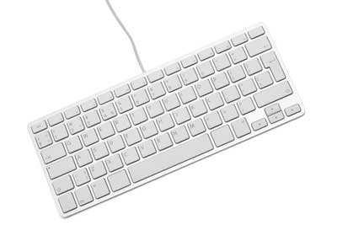

Keyboards are of two sizes 84 keys or 101/102 keys, but now keyboards with 104 keys or 108 keys are also available for Windows and Internet.

The keys on the keyboard are as follows −

|  |  |
| --- | --- |
|  | **Keys & Description** |
|  | **Typing Keys**  These keys include the letter keys (A-Z) and digit keys (09) which generally give the same layout as that of typewriters. |
|  | **Numeric Keypad**  It is used to enter the numeric data or cursor movement. Generally, it consists of a set of 17 keys that are laid out in the same configuration used by most adding machines and calculators. |
|  | **Function Keys**  The twelve function keys are present on the keyboard which are arranged in a row at the top of the keyboard. Each function key has a unique meaning and is used for some specific purpose. |
|  | **Control keys**  These keys provide cursor and screen control. It includes four directional arrow keys. Control keys also include Home, End, Insert, Delete, Page Up, Page Down, Control(Ctrl), Alternate(Alt), Escape(Esc). |
|  | **Special Purpose Keys**  Keyboard also contains some special purpose keys such as Enter, Shift, Caps Lock, Num Lock, Space bar, Tab, and Print Screen. |

## Mouse

Mouse is the most popular pointing device. It is a very famous cursor-control device having a small palm size box with a round ball at its base, which senses the movement of the mouse and sends corresponding signals to the CPU when the mouse buttons are pressed.

Generally, it has two buttons called the left and the right button and a wheel is present between the buttons. A mouse can be used to control the position of the cursor on the screen, but it cannot be used to enter text into the computer.

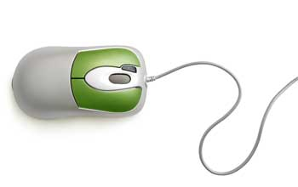

### **Advantages**

* Easy to use
* Not very expensive
* Moves the cursor faster than the arrow keys of the keyboard.

## Joystick

Joystick is also a pointing device, which is used to move the cursor position on a monitor screen. It is a stick having a spherical ball at its both lower and upper ends. The lower spherical ball moves in a socket. The joystick can be moved in all four directions.

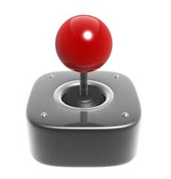

The function of the joystick is similar to that of a mouse. It is mainly used in Computer Aided Designing (CAD) and playing computer games.

## Light Pen

Light pen is a pointing device similar to a pen. It is used to select a displayed menu item or draw pictures on the monitor screen. It consists of a photocell and an optical system placed in a small tube.



When the tip of a light pen is moved over the monitor screen and the pen button is pressed, its photocell sensing element detects the screen location and sends the corresponding signal to the CPU.

## Track Ball

Track ball is an input device that is mostly used in notebook or laptop computer, instead of a mouse. This is a ball which is half inserted and by moving fingers on the ball, the pointer can be moved.

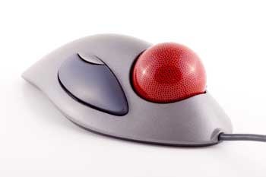

Since the whole device is not moved, a track ball requires less space than a mouse. A track ball comes in various shapes like a ball, a button, or a square.

## Scanner

Scanner is an input device, which works more like a photocopy machine. It is used when some information is available on paper and it is to be transferred to the hard disk of the computer for further manipulation.

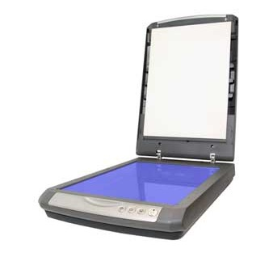

Scanner captures images from the source which are then converted into a digital form that can be stored on the disk. These images can be edited before they are printed.

## Digitizer

Digitizer is an input device which converts analog information into digital form. Digitizer can convert a signal from the television or camera into a series of numbers that could be stored in a computer. They can be used by the computer to create a picture of whatever the camera had been pointed at.

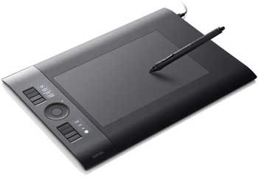

Digitizer is also known as Tablet or Graphics Tablet as it converts graphics and pictorial data into binary inputs. A graphic tablet as digitizer is used for fine works of drawing and image manipulation applications.

## Microphone

Microphone is an input device to input sound that is then stored in a digital form.



The microphone is used for various applications such as adding sound to a multimedia presentation or for mixing music.

## Magnetic Ink Card Reader (MICR)

MICR input device is generally used in banks as there are large number of cheques to be processed every day. The bank's code number and cheque number are printed on the cheques with a special type of ink that contains particles of magnetic material that are machine readable.

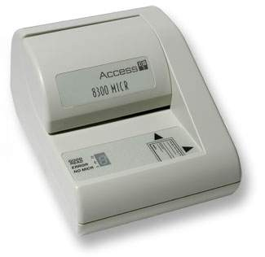

This reading process is called Magnetic Ink Character Recognition (MICR). The main advantages of MICR is that it is fast and less error prone.

## Optical Character Reader (OCR)

OCR is an input device used to read a printed text.

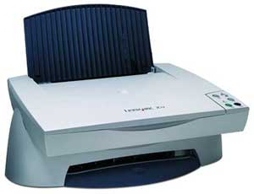

OCR scans the text optically, character by character, converts them into a machine readable code, and stores the text on the system memory.

## Bar Code Readers

Bar Code Reader is a device used for reading bar coded data (data in the form of light and dark lines). Bar coded data is generally used in labelling goods, numbering the books, etc. It may be a handheld scanner or may be embedded in a stationary scanner.

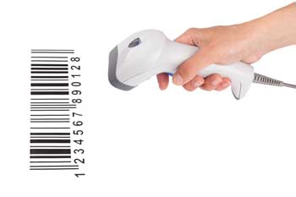

Bar Code Reader scans a bar code image, converts it into an alphanumeric value, which is then fed to the computer that the bar code reader is connected to.

## Optical Mark Reader (OMR)

OMR is a special type of optical scanner used to recognize the type of mark made by pen or pencil. It is used where one out of a few alternatives is to be selected and marked.

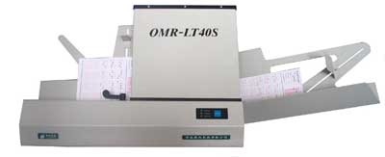

It is specially used for checking the answer sheets of examinations having multiple choice questions.

Following are some of the important output devices used in a computer.

* Monitors
* Graphic Plotter
* Printer

## Monitors

Monitors, commonly called as **Visual Display Unit** (VDU), are the main output device of a computer. It forms images from tiny dots, called pixels that are arranged in a rectangular form. The sharpness of the image depends upon the number of pixels.

There are two kinds of viewing screen used for monitors.

* Cathode-Ray Tube (CRT)
* Flat-Panel Display

### **Cathode-Ray Tube (CRT) Monitor**

The CRT display is made up of small picture elements called pixels. The smaller the pixels, the better the image clarity or resolution. It takes more than one illuminated pixel to form a whole character, such as the letter ‘e’ in the word help.

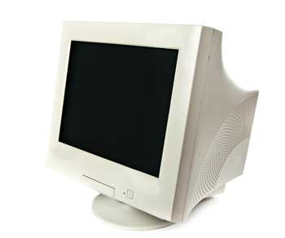

A finite number of characters can be displayed on a screen at once. The screen can be divided into a series of character boxes - fixed location on the screen where a standard character can be placed. Most screens are capable of displaying 80 characters of data horizontally and 25 lines vertically.

There are some disadvantages of CRT −

* Large in Size
* High power consumption

### **Flat-Panel Display Monitor**

The flat-panel display refers to a class of video devices that have reduced volume, weight and power requirement in comparison to the CRT. You can hang them on walls or wear them on your wrists. Current uses of flat-panel displays include calculators, video games, monitors, laptop computer, and graphics display.

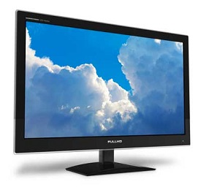

The flat-panel display is divided into two categories −

* **Emissive Displays** − Emissive displays are devices that convert electrical energy into light. For example, plasma panel and LED (Light-Emitting Diodes).
* **Non-Emissive Displays** − Non-emissive displays use optical effects to convert sunlight or light from some other source into graphics patterns. For example, LCD (Liquid-Crystal Device).

## Printers

Printer is an output device, which is used to print information on paper.

There are two types of printers −

* Impact Printers
* Non-Impact Printers

### **Impact Printers**

Impact printers print the characters by striking them on the ribbon, which is then pressed on the paper.

Characteristics of Impact Printers are the following −

* Very low consumable costs
* Very noisy
* Useful for bulk printing due to low cost
* There is physical contact with the paper to produce an image

These printers are of two types −

* Character printers
* Line printers

**Character Printers**

Character printers are the printers which print one character at a time.

These are further divided into two types:

* Dot Matrix Printer(DMP)
* Daisy Wheel

**Dot Matrix Printer**

In the market, one of the most popular printers is Dot Matrix Printer. These printers are popular because of their ease of printing and economical price. Each character printed is in the form of pattern of dots and head consists of a Matrix of Pins of size (5\*7, 7\*9, 9\*7 or 9\*9) which come out to form a character which is why it is called Dot Matrix Printer.

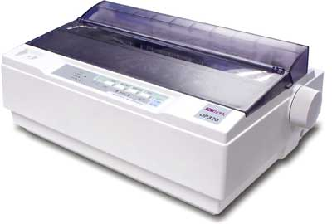

**Advantages**

* Inexpensive
* Widely Used
* Other language characters can be printed

**Disadvantages**

* Slow Speed
* Poor Quality

**Daisy Wheel**

Head is lying on a wheel and pins corresponding to characters are like petals of Daisy (flower) which is why it is called Daisy Wheel Printer. These printers are generally used for word-processing in offices that require a few letters to be sent here and there with very nice quality.

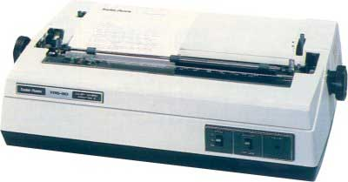

**Advantages**

* More reliable than DMP
* Better quality
* Fonts of character can be easily changed

**Disadvantages**

* Slower than DMP
* Noisy
* More expensive than DMP

**Line Printers**

Line printers are the printers which print one line at a time.

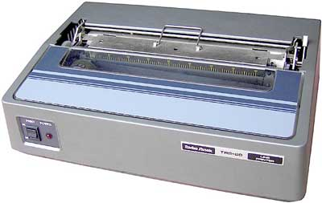

These are of two types −

* Drum Printer
* Chain Printer

**Drum Printer**

This printer is like a drum in shape hence it is called drum printer. The surface of the drum is divided into a number of tracks. Total tracks are equal to the size of the paper, i.e. for a paper width of 132 characters, drum will have 132 tracks. A character set is embossed on the track. Different character sets available in the market are 48 character set, 64 and 96 characters set. One rotation of drum prints one line. Drum printers are fast in speed and can print 300 to 2000 lines per minute.

**Advantages**

* Very high speed

**Disadvantages**

* Very expensive
* Characters fonts cannot be changed

**Chain Printer**

In this printer, a chain of character sets is used, hence it is called Chain Printer. A standard character set may have 48, 64, or 96 characters.

**Advantages**

* Character fonts can easily be changed.
* Different languages can be used with the same printer.

**Disadvantages**

* Noisy

### **Non-impact Printers**

Non-impact printers print the characters without using the ribbon. These printers print a complete page at a time, thus they are also called as Page Printers.

These printers are of two types −

* Laser Printers
* Inkjet Printers

**Characteristics of Non-impact Printers**

* Faster than impact printers
* They are not noisy
* High quality
* Supports many fonts and different character size

**Laser Printers**

These are non-impact page printers. They use laser lights to produce the dots needed to form the characters to be printed on a page.

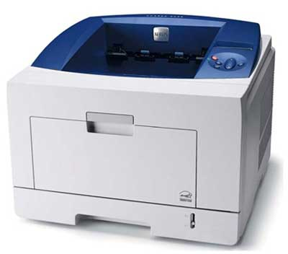

**Advantages**

* Very high speed
* Very high quality output
* Good graphics quality
* Supports many fonts and different character size

**Disadvantages**

* Expensive
* Cannot be used to produce multiple copies of a document in a single printing

**Inkjet Printers**

Inkjet printers are non-impact character printers based on a relatively new technology. They print characters by spraying small drops of ink onto paper. Inkjet printers produce high quality output with presentable features.

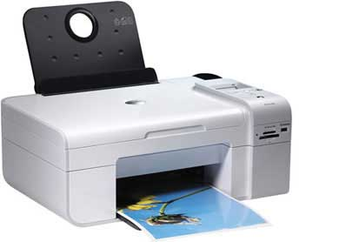

They make less noise because no hammering is done and these have many styles of printing modes available. Color printing is also possible. Some models of Inkjet printers can produce multiple copies of printing also.

**Advantages**

* High quality printing
* More reliable

**Disadvantages**

* Expensive as the cost per page is high
* Slow as compared to laser printer

A memory is just like a human brain. It is used to store data and instructions. Computer memory is the storage space in the computer, where data is to be processed and instructions required for processing are stored. The memory is divided into large number of small parts called cells. Each location or cell has a unique address, which varies from zero to memory size minus one. For example, if the computer has 64k words, then this memory unit has 64 \* 1024 = 65536 memory locations. The address of these locations varies from 0 to 65535.

Memory is primarily of three types −

* Cache Memory
* Primary Memory/Main Memory
* Secondary Memory

## Cache Memory

Cache memory is a very high speed semiconductor memory which can speed up the CPU. It acts as a buffer between the CPU and the main memory. It is used to hold those parts of data and program which are most frequently used by the CPU. The parts of data and programs are transferred from the disk to cache memory by the operating system, from where the CPU can access them.

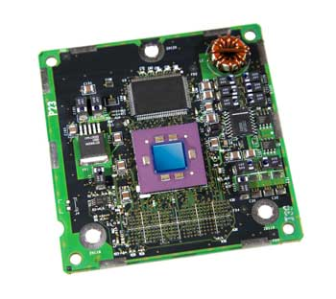

### **Advantages**

The advantages of cache memory are as follows −

* Cache memory is faster than main memory.
* It consumes less access time as compared to main memory.
* It stores the program that can be executed within a short period of time.
* It stores data for temporary use.

### **Disadvantages**

The disadvantages of cache memory are as follows −

* Cache memory has limited capacity.
* It is very expensive.

## Primary Memory (Main Memory)

Primary memory holds only those data and instructions on which the computer is currently working. It has a limited capacity and data is lost when power is switched off. It is generally made up of semiconductor device. These memories are not as fast as registers. The data and instruction required to be processed resides in the main memory. It is divided into two subcategories RAM and ROM.

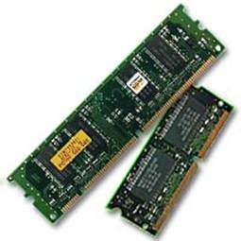

### **Characteristics of Main Memory**

* These are semiconductor memories.
* It is known as the main memory.
* Usually volatile memory.
* Data is lost in case power is switched off.
* It is the working memory of the computer.
* Faster than secondary memories.
* A computer cannot run without the primary memory.

## Secondary Memory

This type of memory is also known as external memory or non-volatile. It is slower than the main memory. These are used for storing data/information permanently. CPU directly does not access these memories, instead they are accessed via input-output routines. The contents of secondary memories are first transferred to the main memory, and then the CPU can access it. For example, disk, CD-ROM, DVD, etc.

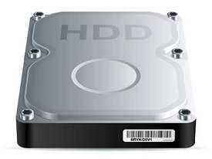

### **Characteristics of Secondary Memory**

* These are magnetic and optical memories.
* It is known as the backup memory.
* It is a non-volatile memory.
* Data is permanently stored even if power is switched off.
* It is used for storage of data in a computer.
* Computer may run without the secondary memory.
* Slower than primary memories.

RAM (Random Access Memory) is the internal memory of the CPU for storing data, program, and program result. It is a read/write memory which stores data until the machine is working. As soon as the machine is switched off, data is erased.



Access time in RAM is independent of the address, that is, each storage location inside the memory is as easy to reach as other locations and takes the same amount of time. Data in the RAM can be accessed randomly but it is very expensive.

RAM is volatile, i.e. data stored in it is lost when we switch off the computer or if there is a power failure. Hence, a backup Uninterruptible Power System (UPS) is often used with computers. RAM is small, both in terms of its physical size and in the amount of data it can hold.

RAM is of two types −

* Static RAM (SRAM)
* Dynamic RAM (DRAM)

## Static RAM (SRAM)

The word **static** indicates that the memory retains its contents as long as power is being supplied. However, data is lost when the power gets down due to volatile nature. SRAM chips use a matrix of 6-transistors and no capacitors. Transistors do not require power to prevent leakage, so SRAM need not be refreshed on a regular basis.

There is extra space in the matrix, hence SRAM uses more chips than DRAM for the same amount of storage space, making the manufacturing costs higher. SRAM is thus used as cache memory and has very fast access.

### **Characteristic of Static RAM**

* Long life
* No need to refresh
* Faster
* Used as cache memory
* Large size
* Expensive
* High power consumption

## Dynamic RAM (DRAM)

DRAM, unlike SRAM, must be continually **refreshed** in order to maintain the data. This is done by placing the memory on a refresh circuit that rewrites the data several hundred times per second. DRAM is used for most system memory as it is cheap and small. All DRAMs are made up of memory cells, which are composed of one capacitor and one transistor.

### **Characteristics of Dynamic RAM**

* Short data lifetime
* Needs to be refreshed continuously
* Slower as compared to SRAM
* Used as RAM
* Smaller in size
* Less expensive
* Less power consumption

ROM stands for **Read Only Memory**. The memory from which we can only read but cannot write on it. This type of memory is non-volatile. The information is stored permanently in such memories during manufacture. A ROM stores such instructions that are required to start a computer. This operation is referred to as **bootstrap**. ROM chips are not only used in the computer but also in other electronic items like washing machine and microwave oven.

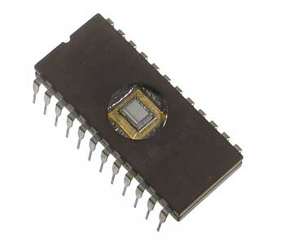

Let us now discuss the various types of ROMs and their characteristics.

## MROM (Masked ROM)

The very first ROMs were hard-wired devices that contained a pre-programmed set of data or instructions. These kind of ROMs are known as masked ROMs, which are inexpensive.

## PROM (Programmable Read Only Memory)

PROM is read-only memory that can be modified only once by a user. The user buys a blank PROM and enters the desired contents using a PROM program. Inside the PROM chip, there are small fuses which are burnt open during programming. It can be programmed only once and is not erasable.

## EPROM (Erasable and Programmable Read Only Memory)

EPROM can be erased by exposing it to ultra-violet light for a duration of up to 40 minutes. Usually, an EPROM eraser achieves this function. During programming, an electrical charge is trapped in an insulated gate region. The charge is retained for more than 10 years because the charge has no leakage path. For erasing this charge, ultra-violet light is passed through a quartz crystal window (lid). This exposure to ultra-violet light dissipates the charge. During normal use, the quartz lid is sealed with a sticker.

## EEPROM (Electrically Erasable and Programmable Read Only Memory)

EEPROM is programmed and erased electrically. It can be erased and reprogrammed about ten thousand times. Both erasing and programming take about 4 to 10 ms (millisecond). In EEPROM, any location can be selectively erased and programmed. EEPROMs can be erased one byte at a time, rather than erasing the entire chip. Hence, the process of reprogramming is flexible but slow.

## Advantages of ROM

The advantages of ROM are as follows −

* Non-volatile in nature
* Cannot be accidentally changed
* Cheaper than RAMs
* Easy to test
* More reliable than RAMs
* Static and do not require refreshing
* Contents are always known and can be verified

**Motherboard** serves as a single platform to connect all of the parts of a computer together. It connects the CPU, memory, hard drives, optical drives, video card, sound card, and other ports and expansion cards directly or via cables. It can be considered as the backbone of a computer.

## Features of Motherboard

A motherboard comes with following features −

* Motherboard varies greatly in supporting various types of components.
* Motherboard supports a single type of CPU and few types of memories.
* Video cards, hard disks, sound cards have to be compatible with the motherboard to function properly.
* Motherboards, cases, and power supplies must be compatible to work properly together.

## Popular Manufacturers

Following are the popular manufacturers of the motherboard.

* Intel
* ASUS
* AOpen
* ABIT
* Biostar
* Gigabyte
* MSI

## Description of Motherboard

The motherboard is mounted inside the case and is securely attached via small screws through pre-drilled holes. Motherboard contains ports to connect all of the internal components. It provides a single socket for CPU, whereas for memory, normally one or more slots are available. Motherboards provide ports to attach the floppy drive, hard drive, and optical drives via ribbon cables. Motherboard carries fans and a special port designed for power supply.

There is a peripheral card slot in front of the motherboard using which video cards, sound cards, and other expansion cards can be connected to the motherboard.

On the left side, motherboards carry a number of ports to connect the monitor, printer, mouse, keyboard, speaker, and network cables. Motherboards also provide USB ports, which allow compatible devices to be connected in plug-in/plug-out fashion. For example, pen drive, digital cameras, etc.

Memory unit is the amount of data that can be stored in the storage unit. This storage capacity is expressed in terms of Bytes.

The following table explains the main memory storage units −

|  |  |
| --- | --- |
|  | **Unit & Description** |
|  | **Bit (Binary Digit)**  A binary digit is logical 0 and 1 representing a passive or an active state of a component in an electric circuit. |
|  | **Nibble**  A group of 4 bits is called nibble. |
|  | **Byte**  A group of 8 bits is called byte. A byte is the smallest unit, which can represent a data item or a character. |
|  | **Word**  A computer word, like a byte, is a group of fixed number of bits processed as a unit, which varies from computer to computer but is fixed for each computer.  The length of a computer word is called word-size or word length. It may be as small as 8 bits or may be as long as 96 bits. A computer stores the information in the form of computer words. |

The following table lists some higher storage units −

|  |  |
| --- | --- |
|  | **Unit & Description** |
|  | **Kilobyte (KB)**  1 KB = 1024 Bytes |
|  | **Megabyte (MB)**  1 MB = 1024 KB |
|  | **GigaByte (GB)**  1 GB = 1024 MB |
|  | **TeraByte (TB)**  1 TB = 1024 GB |
|  | **PetaByte (PB)**  1 PB = 1024 TB |

In the early 1980s, the virus creators or virus writers started writing viruses. During the late 1990s, many of the written viruses were just meant to annoy users and to learn how far a virus can spread. These writers were young or teenage programmers who were ignorant of their mischievous acts.

After learning that viruses can do more, the writers and hackers began to do professional crimes to collect money and data from small businesses to corporate giants to ordinary computer users. The Internet is everyone's tool for to get information, to socialize, and to transact with many businesses and banks. It's where a pile of opportunities for economic exploitation of both corporations and the ordinary computer user.

### **The Definition of Computer Malware**

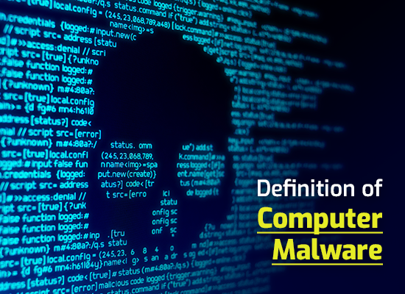

Cyber criminals designed computer programs to penetrate and harm computers without user's content. It's a “malicious software”, or popularly known as a Malware. The term malware covers all the types of threats to your computer safety such as spyware, viruses, worms, trojans, rootkits, and etc. Malware performs a wide range of tasks from stealing, encrypting or deleting sensitive data, altering or hijacking core computing functions, and spying on someone' computer activity without their consent.

* Short for malicious software.
* A is software used or created to disrupt computer operation, gather sensitive information, or gain access to private computer systems.
* It can appear in the form of code, scripts, active content, and other software.
* 'Malware' is a general term used to refer to a variety of forms of hostile, intrusive, or annoying software

How Malware Works

A cyber criminal can use a vast options of spreading the malware and infect gadgets, computers, and networks. Malware can be delivered using a USB drive, downloading programs, email attachments, and etc. Phishing attacks are another popular type of malware execution. Phony emails are disguised as authentic messages from reputable companies or people. It contains malicious links or attachments that allows threat actors to communicate with the infected systems, exfiltrate sensitive data and even remotely control the compromised device or server.

### **Usage of Malware**

* Many early infectious programs, including the first Internet Worm, were written as experiments or pranks.
* Today, malware is used primarily to steal sensitive personal, financial, or business information for the benefit of others.
* Malware is sometimes used broadly against government or corporate websites to gather guarded information, or to disrupt their operation in general.
* However, malware is often used against individuals to gain personal information such as social security numbers, bank or credit card numbers, and so on.

### **Types of Malware Viruses**

* A program or piece of code that is loaded onto your computer without your knowledge and runs against your wishes.
* Viruses can also replicate themselves.
* All computer viruses are man made.
* Viruses copy themselves to other disks to spread to other computers.
* They can be merely annoying or they can be vastly destructive to your files.

### **Examples of computer viruses**

## ****Viruses****

**Vital Information Resource Under Siege**

These two malicious software are designed to disseminate without the knowledge of the users. The virus attaches itself to a legitimate software. When the software was used, by the computer owner it spreads the virus. A virus needs a human action before they can spread themselves. However, a computer worm spreads without any actions.

**Examples of computer viruses are:**

**Resident Viruses -**Is a permanent which dwells in the RAM memory.

**Direct action Viruses-**  the main purpose is to replicate and take action when it is executed.

**Overwrite Viruses-**  it deletes the information contained in the files that it infects.

**Boot Sector Viruses-**   A computer virus that infects the sectors on a disk that contain the data a computer uses during the boot process.

**Macro Viruses -**  infect files that are created using certain applications or programs that contains macros.

**Directory Viruses -**  change the paths that indicate the location of the file.

**Polymorphic Viruses -**  encrypt and encode themselves in a different way.

**File infector / File Viruses -**  a type of virus that infect the programs or executable file (.exe or .com) .

Companion Viruses -   can be considered file infector viruses like resident or direct action type.

**FAT(File Allocation Table) Viruses -**  dangerous, by preventing access to certain sections of the disk.

## WORM

## Write Once Read Many

A software program designed to enter a computer system, usually a network, through security "holes" and replicate itself.

### Cyber security flat icon**Trojan Horses**

* A Trojan Horse program has the appearance of having a useful and desired function.
* A Trojan Horse neither replicates nor copies itself, but causes damage or compromises the security of the computer.
* A Trojan Horse must be sent by someone or carried by another program and may arrive in the form of a joke program or software of some sort.
* These are often used to capture your logins and

Example of Trojan Horses • Remote access Trojans (RATs) • Backdoor Trojans (backdoors) • IRC Trojans (IRCbots) • Keylogging Trojans

### **Worms**

* A computer worm is a self-replicating computer program.
* It uses a network to send copies of itself to other nodes (computers on the network) and it may do so without any user intervention.
* It does not need to attach itself to an existing program.

### **Spyware**

* Spyware is a type of malware installed on computers that collects information about users without their knowledge.
* The presence of spyware is typically hidden from the user and can be difficult to detect.
* Spyware programs lurk on your computer to steal important information, like your passwords and logins and other personal identification information and then send it off to someone else.

### **Zombie**

* Zombie programs take control of your computer and use it and its Internet connection to attack other computers or networks or to perform other criminal activities.

### **Phishing**

* Phishing (pronounced like the word 'fishing') is a message that tries to trick you into providing information like your social security number or bank account information or logon and password for a web site.
* The message may claim that if you do not click on the link in the message and log onto a financial web site that your account will be blocked, or some other disaster.

**Spam**

* Spam is email that you did not request and do not want.
* One person's spam is another's useful newsletter or sale ad.
* Spam is a common way to spread viruses, trojans, and the like.

### **Adware**

* Adware (short for advertising-supported software) is a type of malware that automatically delivers advertisements.
* Common examples of adware include pop-up ads on websites and advertisements that are displayed by software.
* Often times software and applications offer “free” versions that come bundled with adware.

### **Ransomware**

* Ransomware is a form of malware that essentially holds a computer system captive while demanding a ransom.
* The malware restricts user access to the computer either by encrypting files on the hard drive or locking down the system and displaying messages that are intended to force the user to pay the malware creator to remove the restrictions and regain access to their computer.

### **How Malware Spreads?**

* Malware is a program that must be triggered or somehow executed before it can infect your computer system and spread to others.
* Here are some examples on how malware is distributed:

1. a) Social network
2. b) Pirated software
3. c) Removable media
4. d) Emails e) Websites

### **Damages**

1. Data Loss
   * Many viruses and Trojans will attempt to delete files or wipe hard drives when activated, but even if you catch the infection early, you may have to delete infected files.
2. Account Theft

* Many types of malware include keylogger functions, designed to steal accounts and passwords from their targets.
* This can give the malware author access to any of the user's online accounts, including email servers from which the hacker can launch new attacks.

1. Botnets

* Many types of malware also subvert control over the user's computer, turning it into a "bot" or "zombie."
* Hackers build networks of these commandeered computers, using their combined processing power for tasks like cracking password files or sending out bulk emails.

1. Financial Losses

* If a hacker gains access to a credit card or bank account via a keylogger, he can then use that information to run up charges or drain the account. • Given the popularity of online banking and bill payment services, a hacker who manages to secrete a keylogger on a user's system for a full month may gain access to the user's entire financial portfolio, allowing him to do as much damage as possible in a single attack.

### **Symptoms**

* Increased CPU usage
* Slow computer or web browser speeds
* Problems connecting to networks
* Freezing or crashing
* Modified or deleted files
* Appearance of strange files, programs, or desktop icons
* Programs running, turning off, or reconfiguring themselves (malware will often reconfigure or turn off antivirus and firewall programs)

## Strange computer behavior

* Emails/messages being sent automatically and without user’s knowledge (a friend receives a strange email from you that you did not send)
* There seems to be a lot of network activity when you are not using the network
* The available memory on your computer is lower than it should be
* Programs or files appear or disappear without your knowledge
* File names are changed

### **How Can You Protect Your Computer?**

* Install protection software.
* Practice caution when working with files from unknown or questionable sources.
* Do not open e-mail if you do not recognize the sender.
* Download files only from reputable Internet sites.
* Install firewall.
* Scan your hard drive for viruses monthly

## ****Using the following techniques:****

**Biometrics**

– Biological measurements, such as fingerprinting, that are used in the context of computers to verify a person’s identity.

**User rights**

-Rules that specify the directories and files that an individual user can access.

**Key**

-In the context of data encryption, a key is the method used to encrypt or decipher information as in which numbers in a code match each letters of the alphabet.

**Trap door**

-A way to bypass the normal security precautions and enter a computer system. It is often created during computer installation and testing but should be removed before the computer is placed into service.

**Encryption**

-The process of scrambling or hiding information so that it cannot be understood without the key necessary to change it back into it’s original form.

**Pretty Good Privacy (PGP)**

* A popular public key encryption system.

**Public key encryption (PKE)**

An encryption method that uses a pair of keys, a public key (known to everyone) that encrypts the message and a private key (known only to the recipient) that decrypts it.

### **Anti-Malware Program**

* Anti-Malware program is used to prevent, detect, and remove computer viruses, worms, trojan horses and any other type of malware.
* Examples of Anti-Malware program:

 – Antivirus program

 – Anti-spyware program

– Anti-spam program – Firewall

### **Antivirus Program**

* “Antivirus" is protective software designed to defend your computer against malicious software.
* In order to be an effective defense, the antivirus software needs to run in the background at all times, and should be kept updated so it recognizes new versions of malicious software.

### **Examples of Antivirus Program**

* + Norton Antivirus
  + AVG
  + Kaspersky
  + Avast!
  + PC-Cilin
  + McAffee
  + Avira

### **Anti-Spyware Program**

* Anti-spyware program is a type of program designed to prevent and detect unwanted spyware program installations and to remove those programs if installed.
* Examples of Anti-spyware program:

– Spyware Doctor

 – AVG Anti-spyware

– STOPzilla

– Spysweeper

* Anti-spam software tries to identify useless or dangerous messages for you.

### **Firewall**

* A firewall blocks attempts to access your files over a network or internet connection.
* That will block incoming attacks.
* Your computer can become infected through shared disks or even from another computer on the network.
* So you need to monitor what your computer is putting out over the network or internet also.

### **Terminologies to Remember**

**Crackers**

-People who break into a computer system with intent to damage files or steal data.

**Cyberpunks**

– People who break into computers, especially Internet computers, to steal data modify files or plant viruses.

**Hackers**

-People who are once meant as computer hobbyists or computer novice. Today they are referred to as people who has gained illegal access in a computer system.

## ****Data security****

-Techniques that provide protection for data.

### **Safe computing TIPS**

1.Never boot from any devices unless you are sure that it is virus free

2.Check all new software for the presence of viruses

3.If you own laptop, make sure that it is stored in a safe place

4.Keep storage devices containing important information in a safe place.

5.Make it to habit to backup regularly

6.Know the computer that you are using

7.Keep your password secured

8.Avoid letting just anyone use your computer

## ****Law of Computer System****

1. **Contract Law**
   * Software license agreements, including “shrink-wrap”
   * Business transactions in cyberspace
   * Contracts for data processing services
   * Contracts for development of custom software or hardware

1. **Copyright Law**
   * Copyright protection for computer software
   * Copyright protection for text or pictures on Internet

1. **Trademark Law**
   * Domain name disputes
   * Infringement or dilution of trademarks on Internet

1. **Patent Law**
   1. Patent for novel software
   2. Patents for computer hardware

1. **Tort Law**
   * Defamation
   * Trade disparagement, unfair competition law
   * Duty to maintain secure data

1. **Computer crime**
   * Unauthorized use of services
   * Denial of services attacks on websites
   * Larcency, malicious mischief, vandalism etc.
   * Fraud (scam)
   * Malicious computer programs (computer viruses, trojan, worm)
   * Obscenity, harassment by e-mail

1. **Utility Law or Telecommunication Law**
   * Tariffs for Internet traffic via long-distance telephone carrier
   * Possible regulation of Internet Services Providers

1. **Constitutional Law**
   * Freedom of Speech on the Internet
   * Search and Seizure Law

**SOFTWARE:**

- is the non-physical components of the computer that are intangible in nature.

**Categories of Software:**

1. **System Software** – refers to the programs that assists in the computer operations in general thereby facilitating of applications programs.

**Types of System software:**

* **Operating Systems** – refers to a group of related programs that supervise the execution of an application program.
* **Operating Environment**- refers to programs that sit on top of OS.
* **Utilities**– a single term for all types of programming aids.
* **Programming languages** – the programs used to write other programs
* **Language processor** – known as translators, used to convert source program into a form suitable for execution
  + **Compilers** – it translates programs written in high-level languages into machine instructions understandable by the computer**.**
  + **Assemblers** – it translate the source program written in Assembly language
  + **Interpreters**– it performs each instructions immediately after translation.

1. **Application Software** – user programs designed to solve problems such as those use in business, engineering and scientific research

**Types of Application software:**

* **Package programs** – commonly called ‘application package’ which are useful to several users.

**Types of Package programs:**

* **Word processing software** – it allows inserting, deleting, storing m restoring and printing of documents. Ex. MS Word, Wordstar, Wordperfect
* **Desktop Publishing software** – combines hardware and software to enable the user to combine text and images on the same page in a professional, publishable format for printing. Ex. Pagemaker, Adobe
* **Spreadsheet Software** – allows the user to create worksheets/tables of data for financial analysis. Ex. MS Excel, Lotus 123,Quato, Visicalc
* **Database Management System (DBMS)** – also known as database manager, consists of programs used for maintaining a database or a pool of data. Ex. Foxbase, dBase IV, MS Access, Oracle
* **Graphics Software** – allows the user to make reports and other presentations using graphs and freedom drawings. Ex. Paintbrush, Newsmaster,Printshop, MS Paint, Powerpoint.
* **Communication Software** – allows the user to access software and data from and to a computer at a remote location.Ex. Global chat, Freetel, PCTalk, PC Dial, Ms Netmeeting.
* **Integrated Software** – it allows the user to create spreadsheets, databases, graphics and communication software. Ex. MS Office, Perfect, Office,Smart suite.
* **Groupware**– it is used on networks of computer users working together on the same projects. Ex. Lotus notes, MS Works
* **Software Suites** – combination ofspreadsheet, word processor, graphics, communications and groupware in one software. Ex. MS Office, SmartSuite, Perfect Office.
* **Desktop Accessories**– serve as organizer of collected, small programs. Ex. Sidekick, electronic tools as calendar, clock, card file, calculator and notepad.
* **PIM (Personal Information Manager)** –it helps organize personal information such as addresses and telephone numbers. Ex. MS Outlook
* **Project Management Software** – used to monitor large –scale projects using this software prior to manufacturing. Ex. Orcad, Supervision, AutoCAD
* **Multimedia Software** - allows the use of text, graphics, animation, video and sound. Ex. Multimedia toolbox, Autorware, Multimedia Works.

* **Custom Programs** – specifically written for an organization or a single user using any programming language. Ex. Accounting system, Enrolment System, Grading system

**Levels of Programming Languages:**

1. **Machine Language**  - language that the computer could directly understand. It uses symbols (string of 1’s and 0’s) to represent data and information’s.
2. **Symbolic Language** – language that uses abbreviated instructions called mnemonics.
3. **High-level Language** – language that is directly understandable to the human being, It uses decimal representation for numbers.

PEOPLEWARE:

 – refers to the personnel involved in data processing operations.

**Functional Areas of Peopleware:**

* Systems Programming
* System analysts
* Application programming
* Computer Operations

**Personnel:**

* Data Entry Operator
* Computer Operator
* Computer Programmer
* System Analysts
* Computer Center Director
* Database Administrator

**DATAWARE  or PROCEDURE** :

– refers to rules and policies that govern the operations of the whole computer system.

**Examples of Dataware:**

* Instruction Manuals
* Operating Procedures
* Processing Procedures
* **Question 1**
* **1 / 1 pts**
* Interprets program instructions   and directs the other parts of the CPU, and communicates with   the external input/output devices and secondary storage
* 
* memory
* 
* processor
* 
* ports
* 
* slots

* **Question 2**
* **1 / 1 pts**
* refers to a group of related programs that supervise   the execution of an application program
* 
* programming language
* 
* utilities
* 
* operating system
* 
* language processor

* **Question 3**
* **1 / 1 pts**
* It facilitate the connection between computers connected with a network of computers over phone lines and other channels.
* 
* communication hardware
* 
* Input and Output Unit
* 
* storage hardware
* 
* output hardware

* **Question 4**
* **1 / 1 pts**
* refers to rules and policies that govern the operations of the whole computer system
* 
* programming language
* 
* peopleware
* 
* none of the choices
* 
* dataware

* **Question 5**
* **1 / 1 pts**
* it allows communication between the computer and its outside world via input and output devices.
* 
* Input and Output Unit
* 
* Memory
* 
* none of the choices
* 
* processor

* **Question 6**
* **1 / 1 pts**
* Interprets program instructions   and directs the other parts of the CPU, and communicates with   the external input/output devices and secondary storage
* 
* CU
* 
* none of the choices
* 
* ALU
* 
* memory

* **Question 7**
* **1 / 1 pts**
* this is known as the processor
* 
* ALU
* 
* CPU
* 
* none of the choices
* 
* CU

* **Question 8**
* **1 / 1 pts**
* used to convert source program into a form   suitable for execution
* 
* operating system
* 
* programming language
* 
* language processor
* 
* utility software

* **Question 9**
* **1 / 1 pts**
* It temporarily or permanently store data used for processing and the output of such processing.
* 
* dataware
* 
* hardware
* 
* peopleware
* 
* none of the choices

* **Question 10**
* **1 / 1 pts**
* It provide a means for the user to view information  produced by the computer system.
* 
* storage hardware
* 
* none of the choices
* 
* Input and Output Unit
* 
* output hardware

* **Question 11**
* **1 / 1 pts**
* Which one of the following describes why firewalls are used?
* 
* To prevent destruction of a computer in the event of a fire.
* 
* To prevent unauthorised access by incoming transmissions.
* 
* To enable easy downloading of data from web sites.
* 
* To detect and disable viruses already on a computer

* **Question 12**
* **1 / 1 pts**
* Which one of the following statements about a password is TRUE?
* 
* It cannot contain special character symbols.
* 
* It should be changed regularly
* 
* It must be changed only if it is compromised.
* 
* It must be registered with the system administrator.

* **Question 13**
* **1 / 1 pts**
* Which one of the following is unsafe online activity?
* 
* Using a screen name or nick name that cannot identify you.
* 
* Giving your home address to someone you met in a chat room.
* 
* Keeping your social network profile private.
* 
* Meeting someone you met online face-to-face in the company of your parents.

* **Question 14**
* **1 / 1 pts**
* Which one of the following describes a computer hacker?
* 
* A skilled programmer who helps in the installation of new software for an organisation.
* 
* A skilled programmer who uses authorised access to exploit information available on a computer.
* 
* A skilled programmer who secretly invades computers without authorisation.
* 
* A skilled programmer who writes programs to train new employees.

* **Question 15**
* **1 / 1 pts**
* Which one of the following describes how to find out about an organisation’s privacy policy?
* 
* By speaking to the Sales Department
* 
* By reading the policy in the organisation’s policy manual.
* 
* By speaking to the Finance Department.
* 
* By reading the office newsletter.

* **Question 16**
* **1 / 1 pts**
* Which one of the following describes what you should do if you receive a chain letter email?
* 
* Send a read receipt.
* 
* Download it onto your system.
* 
* Delete the email.
* 
* Forward the email.

* **Question 17**
* **1 / 1 pts**
* Which one of the following describes how confidential information should be sent using an unsecured network?
* 
* In an encrypted format.
* 
* In an unsigned email.
* 
* In an attachment.
* 
* In a compressed format.

* **Question 18**
* **1 / 1 pts**
* Which one of the following should you approach if you are unsure of the IT security procedure to follow when uninstalling an application on  
  your computer?
* 
* The Maintenance Department.
* 
* a technically well-informed member
* 
* The Systems Administrator.
* 
* A senior colleague in the Finance Department.

* **Question 19**
* **1 / 1 pts**
* Which one of the following describes why you should follow guidelines and procedures while using IT resources in an organization?
* 
* To ensure the IT Department is able to monitor all activity.
* 
* To ensure the secure use of IT resources.
* 
* To ensure the Finance Department is able to monitor the costs of IT resources.
* 
* To ensure easy access to information on your computer.

* **Question 20**
* **1 / 1 pts**
* Which one of the following shows respect for confidentiality of information?
* 
* all of the choices
* 
* Emailing confidential information to a colleague.
* 
* Uploading confidential information to a shared web site.
* 
* Disclosing confidential information only to authorised individuals.

* **Question 21**
* **1 / 1 pts**
* These act as “servers” which are connected to several workstations or terminals
* 
* Electronic Devices
* 
* Server
* 
* Supercomputer
* 
* Minicomputers

* **Question 22**
* **1 / 1 pts**
* These are types of Malware Viruses EXCEPT:
* A. Viruses can also replicate themselves.
* B. All computer viruses can be transferred to human.
* C. Viruses copy themselves to other disks to spread to other computers.
* D. They can be merely annoying or they can be vastly destructive to your files.
* 
* B
* 
* C
* 
* D
* 
* A

* **IncorrectQuestion 23**
* **0 / 1 pts**
* A program is used to prevent, detect, and remove computer viruses, worms, trojan horses among others.
* 
* Firewall
* 
* Anti-spyware Program
* 
* Anti-Malware Program
* 
* Antivirus Program

* **Question 24**
* **1 / 1 pts**
* A protective software designed to defend your computer against malicious software.
* 
* Anti-spyware Program
* 
* Antivirus Program
* 
* Anti-Malware Program
* 
* Firewall

* **Question 25**
* **1 / 1 pts**
* A program has the appearance of having a useful and desired function.
* 
* Trojan horses
* 
* Phishing
* 
* Zombie
* 
* Spyware

* **Question 26**
* **1 / 1 pts**
* A type of malware installed on computers that collects information about users without their knowledge.
* 
* Trojan horses
* 
* Spam
* 
* Spyware
* 
* Zombie

* **Question 27**
* **1 / 1 pts**
* These are pop-up ads on websites and advertisements that are displayed by software.
* 
* Financial Losses
* 
* Adware
* 
* Data loss
* 
* Ransomware

* **Question 28**
* **1 / 1 pts**
* A message that tries to trick you into providing information like your social security number or bank account information or logon and password for a web site.
* 
* Spyware
* 
* Phishing
* 
* Zombie
* 
* Trojan horses

* **Question 29**
* **1 / 1 pts**
* It is an electronic data processing device designed to accept and manipulate data and instructions.
* 
* Calculator
* 
* Abacus
* 
* Computer
* 
* IC

* **IncorrectQuestion 30**
* **0 / 1 pts**
* If a hacker gains access to a credit card or bank account via a keylogger, he can then use that information to run up charges or drain the account.
* 
* Adware
* 
* Ransomware
* 
* Financial Losses
* 
* Botnets

* **Question 31**
* **1 / 1 pts**
* Computers can take a series of instructions and automatically execute each instructions one after another
* 
* Programmable
* 
* Repetitiveness
* 
* Speed
* 
* Storage

* **Question 32**
* **1 / 1 pts**
* A form of malware that essentially holds a computer system captive while demanding a ransom.
* 
* Financial Losses
* 
* Adware
* 
* Botnets
* 
* Ransomware

* **Question 33**
* **1 / 1 pts**
* Statement A: A computer worm is a self-replicating computer program.
* Statement B: It uses a network to send copies of itself to other nodes (computers on the network) and it may do so without any user intervention.
* Statement C: It needs to attach itself to an existing program.
* Which of the above statement is False?
* 
* Both Statement A and B
* 
* Statement A
* 
* Statement C
* 
* Statement B

* **Question 34**
* **1 / 1 pts**
* Classification of computer designed to do specific task
* 
* none of the choices
* 
* Special-purpose computers
* 
* General-purpose computers-
* 
* Analog computer

* **Question 35**
* **1 / 1 pts**
* It incorporates in a single machine the capabilities of the analog and digital computers.
* 
* None of the above
* 
* Analog Computers
* 
* Hybrid Computers
* 
* Digital Computers

* **Question 36**
* **1 / 1 pts**
* It blocks attempts to access your files over a network or internet connection.
* 
* Firewall
* 
* Antivirus Program
* 
* Anti-Malware Program
* 
* Anti-spyware Program

* **Question 37**
* **1 / 1 pts**
* These are unsolicited emails in your inbox.
* 
* Zombie
* 
* Spyware
* 
* Spam
* 
* Phishing

* **IncorrectQuestion 38**
* **0 / 1 pts**
* These programs take control of your computer and use it and its Internet connection to attack other computers or networks or to perform other criminal activities.
* 
* Spam
* 
* Zombie
* 
* Spyware
* 
* Zombie

* **Question 39**
* **1 / 1 pts**
* A type of program designed to prevent and detect unwanted spyware program installations and to remove those programs if installed.
* 
* Antivirus Program
* 
* Anti-spyware Program
* 
* Anti-Malware Program
* 
* Firewall

* **Question 40**
* **1 / 1 pts**
* These are devices powered by hand and require physical effort from the user.
* 
* Manual-Mechanical Device
* 
* Electro-mechanical Devices
* 
* Electronic Devices
* 
* Digital Device

* **Question 41**
* **1 / 1 pts**
* Capability of computers that can process the data prepared by the users.
* 
* Speed
* 
* Accuracy
* 
* Repetitiveness
* 
* Storage

* **IncorrectQuestion 42**
* **0 / 1 pts**
* Malware attempt to delete files or wipe hard drives when activated, but even if you catch the infection early, you may have to delete infected files.
* 
* Data loss
* 
* Financial Losses
* 
* Botnets
* 
* Data loss

* **Question 43**
* **1 / 1 pts**
* This can give the malware author access to any of the user's online accounts, including email servers from which the hacker can launch new attacks.
* 
* Account Theft
* 
* Financial Losses
* 
* Botnets
* 
* Data loss

* **Question 44**
* **1 / 1 pts**
* Many types of malware also subvert control over the user's computer, turning it into a "bot" or "zombie."
* 
* Ransomware
* 
* Adware
* 
* Botnets
* 
* Financial Losses

* **Question 45**
* **1 / 1 pts**
* Statement A: One person's spam is another's useful newsletter or sale ad.
* Statement B. Spam is a common way to spread viruses, trojans, and the like.
* Which is TRUE with the above statements?
* 
* Only Statement B
* 
* Only Statement A
* 
* Both Statement A and B
* 
* Both Statements are FALSE

* **Question 46**
* **1 / 1 pts**
* Machine which are in the middle of microcomputers and mainframes in terms of cost and capability.
* 
* Mainframe
* 
* Microcomputers
* 
* Minicomputers
* 
* Supercomputer

* **Question 47**
* **1 / 1 pts**
* A characteristic of computer that  needs human intervention to operate.
* 
* an electronic
* 
* has memory
* 
* a machine
* 
* can manipulate data

* **Question 48**
* **1 / 1 pts**
* A characteristic of a computer that can store and retrieve information.
* 
* a machine
* 
* has logic function
* 
* an electronic
* 
* has memory

* **Question 49**
* **1 / 1 pts**
* Here are some examples on how malware is distributed EXCEPT:
* 
* Texting
* 
* Pirated software
* 
* Social network
* 
* Removable media

* **Question 50**
* **1 / 1 pts**
* Computers can detect and correct errors.
* 
* True
* 
* False
* Cannot correct errors. It can only detect them.

## ****Data Communication****

Data communications refers to the transmission of this digital data between two or more computers and a computer network or data network is a telecommunications network that allows computers to exchange data. The physical connection between networked computing devices is established using either cable media or wireless media.

### **Computer Network**

is a collection of computers which are connected to one another.

### **Network Media**

* + is the actual path over which an electrical signal travels as it moves from one component to another.
  + refers to the materials used to transmit data from its source to its destination.

**Types of Network Media**

**1. Twisted – Pair Cable**

is a type of cabling that is used for telephone communications and most modern Ethernet networks.

A pair of wires forms a circuit that can transmit data. The pairs are twisted to provide protection against *crosstalk* and *cancellation effects.*

## ****Types of Twisted – Pair Cable****

**1.1 Unshielded Twisted–Pair (UTP) Cable 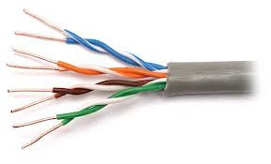**

* + is a medium that is composed of pairs of wires.
  + UTP cable is used in a variety of networks. Each of the eight individual copper wires in UTP cable is covered by an insulating material.
  + In addition, the wires in each pair are twisted around each other.

**1.2 Shielded Twisted–Pair (STP) Cable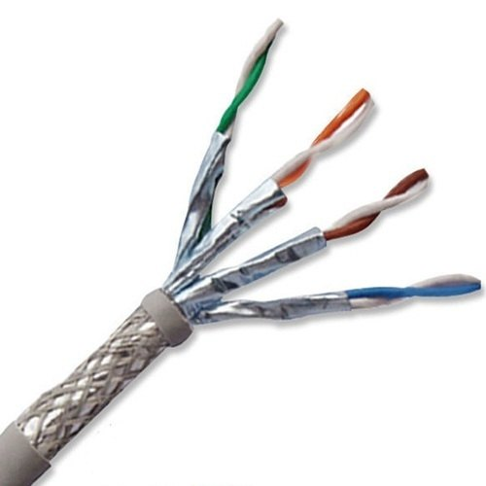**

* + combines the techniques of shielding, cancellation, and wire twisting. Each pair of wires is wrapped in a metallic foil.
  + As speciﬁed for use in Ethernet network installations, STP reduces electrical noise both within the cable (pair-to-pair coupling, or crosstalk) and from outside the cable (EMI and RFI).
  + STP usually is installed with STP data connector, which is created especially for the STP cable.

## ****2. Coaxial Cable****What is a coaxial cable? A definition from WhatIs.com

* + Commonly known as “Coax” , is widely used in cable TV.
  + Supports 10 to 100 Mbps and is relatively inexpensive, although it is more costly than UTP on a per-unit length. However, coaxial cable can be cheaper for a physical bus topology because less cable will be needed.

## Two Types of Coaxial Cable

**2.1 Thick Coaxial Cable (Thicknet)**

* + 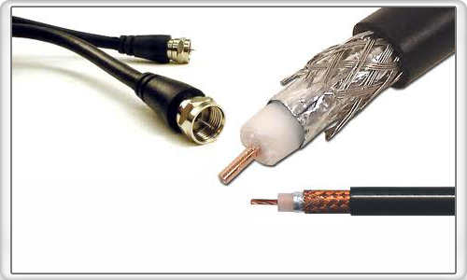The largest diameter (1 cm) was speciﬁed for use as Ethernet backbone cable because historically it had greater transmission length and noise-rejection characteristics.
  + can be too rigid to install easily in some situations because of its thickness.
  + The general rule is that the more difficult the network medium is to install, the more expensive it is to install.

**2.2 Thin Coaxial Cable (Thinnet)**

ØIt has a diameter of only 0.35 cm was used in Ethernet networks.

ØThinnet was especially useful for cable installations that required the cable to make many twists and turns. Because it was easier to install, it was also cheaper to install. Thus, it was sometimes referred to as *Cheapernet.*

### **3. Fiber – Optic Cable**

### The FOA Reference For Fiber Optics - Fiber Optic Cables

 is technologically advanced as compared to the twisted-pair wire and the coaxial cable. Instead of transmitting frequencies, it transmits pulsating *beams of light*. Since, light travels much faster than electricity, fiber-optic  cable can carry a greater volume of data. Also immune from electromagnetic interference which is a problem for copper-based medium.

## ****Wireless Communications****

## Uses radio frequencies (RF) or infrared (IR) waves to transmit data between devices on a LAN. For wireless LANs, a key component is the wireless hub, or access point, used for signal distribution.

### **Wireless Links**How to use snooper in Mikrotik to choose the best frequency for ...

* + These are instances when the use of coaxial cable, fiber-optic cable or twisted-pair wire is impossible or impractical.
  + If the place is very far apart or are blocked by natural occurring or man-made obstacles, the solution is to use wireless links.

Infrared

Low frequency infrared waves are used for very short distance communication like TV remote, wireless speakers, automatic doors, hand held devices etc. Infrared signals can propagate within a room but cannot penetrate walls. However, due to such short range, it is considered to be one of the most secure transmission modes.

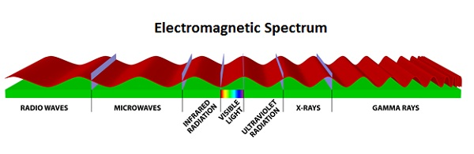

### **Microwave radio signals**

data can also be transmitted via microwave radio signals. Data transmission of this means make us of the principle of *line of sight*.

## Radio Wave

Transmission of data using radio frequencies is called **radio-wave transmission**. We all are familiar with radio channels that broadcast entertainment programs. Radio stations transmit radio waves using **transmitters**, which are received by the receiver installed in our devices.

Both transmitters and receivers use antennas to radiate or capture radio signals. These radio frequencies can also be used for **direct voice communication** within the **allocated range**. This range is usually 10 miles.

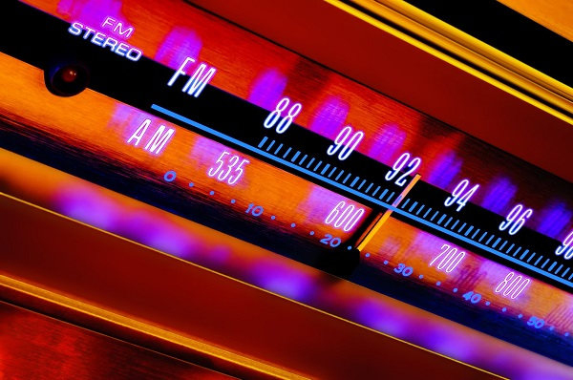

### **Advantages of Radio Wave**

These are some of the advantages of radio wave transmissions −

* Inexpensive mode of information exchange
* No land needs to be acquired for laying cables
* Installation and maintenance of devices is cheap

### **Disadvantages of Radio Wave**

These are some of the disadvantages of radio wave transmissions −

* Insecure communication medium
* Prone to weather changes like rain, thunderstorms, etc.

### **Satellite in Geosynchronous Orbits**

Geosynchronous orbit permits the communications satellite to maintain a fixed position relative to the surface of the earth.

## ****Data Communication Hardware****

**Components:**

* Modem (Modulation, Demodulation) – convert the computer signals to the telephone’s analog signals and vice versa.
* Down line Processors – used to collect data from low-speed devices such as terminals and serial printer.
* Front end Processors

- relieves the host processor of tasks related to data communications such as message routing, encryption and decryption  of data etc.

**Source** – the terminal sending a message or data.

**Destination** – the one receiving the message or data.

**Handshaking** – the task of linking the source and   destination.

### **Types of Computer Network**

* Networks can be categorized depending on size, complexity, level of security, or geographical range. We will discuss some of the most popular topologies based on geographical spread.

## PAN

* + 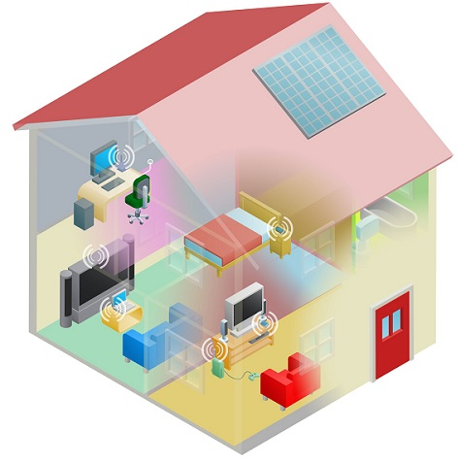

PAN is the acronym for Personal Area Network. PAN is the interconnection between devices within the range of a person’s private space, typically within a range of 10 metres. If you have transferred images or songs from your laptop to mobile or from mobile to your friend’s mobile using Bluetooth, you have set up and used a personal area network.

A person can connect her laptop, smart phone, personal digital assistant and portable printer in a network at home. This network could be fully Wi-Fi or a combination of wired and wireless.

## LAN

 LAN or Local Area Network is a wired network spread over a single site like an office, building or manufacturing unit. LAN is set up to when team members need to share software and hardware resources with each other but not with the outside world. Typical software resources include official documents, user manuals, employee handbook, etc. Hardware resources that can be easily shared over the network include printer, fax machines, modems, memory space, etc. This decreases infrastructure costs for the organization drastically.

* + 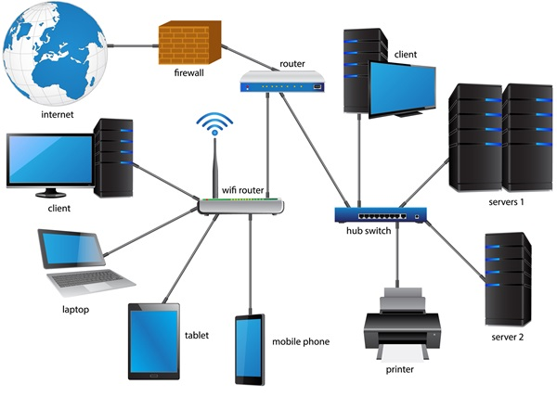

A LAN may be set up using wired or wireless connections. A LAN that is completely wireless is called Wireless LAN or WLAN.

## MAN

MAN is the acronym for Metropolitan Area Network. It is a network spread over a city, college campus or a small region. MAN is larger than a LAN and typically spread over several kilometres. Objective of MAN is to share hardware and software resources, thereby decreasing infrastructure costs. MAN can be built by connecting several LANs.

* + The most common example of MAN is cable TV network.

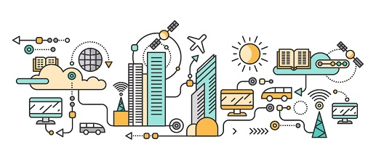

## WAN

* + - 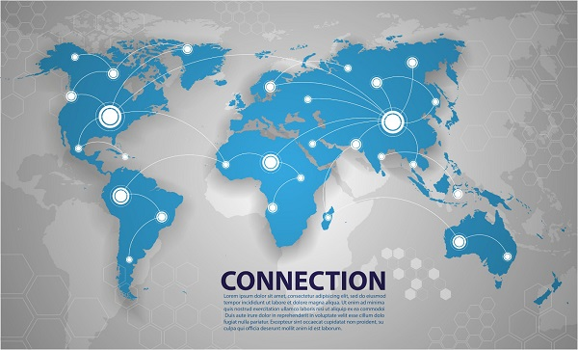WAN or Wide Area Network is spread over a country or many countries. WAN is typically a network of many LANs, MANs and WANs. Network is set up using wired or wireless connections, depending on availability and reliability.

### **The Client – Server Relationship**

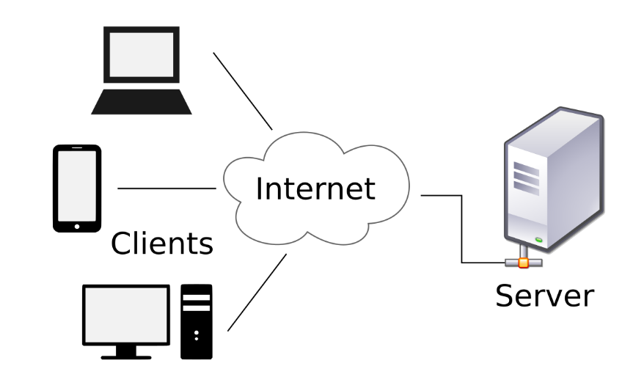 Server – one particular computer is used for a specialized task of serving the needs of each node.

* The nodes(client) accesses the server in order to perform a particular function.
* Peer to Peer relationship
* the nodes(individual computer) of a network can act as server

### **Network Topology**

* refers to the physical connection of wires that connect the nodes of the network.
* is the arrangement with which computer systems or network devices are connected to each other. Topologies may define both physical and logical aspect of the network. Both logical and physical topologies could be same or different in a same network.

The way in which devices are interconnected to form a network is called network topology. Some of the factors that affect choice of topology for a network are −

* **Cost** − Installation cost is a very important factor in overall cost of setting up an infrastructure. So cable lengths, distance between nodes, location of servers, etc. have to be considered when designing a network.
* **Flexibility** − Topology of a network should be flexible enough to allow reconfiguration of office set up, addition of new nodes and relocation of existing nodes.
* **Reliability** − Network should be designed in such a way that it has minimum down time. Failure of one node or a segment of cabling should not render the whole network useless.
* **Scalability** − Network topology should be scalable, i.e. it can accommodate load of new devices and nodes without perceptible drop in performance.
* **Ease of installation** − Network should be easy to install in terms of hardware, software and technical personnel requirements.
* **Ease of maintenance** − Troubleshooting and maintenance of network should be easy.

### **Bus Topology**

Data network with bus topology has a **linear transmission cable**, usually **coaxial**, to which many **network devices** and **workstations** are attached along the length. **Server** is at one end of the bus. When a workstation has to send data, it transmits **packets** with **destination address** in its header along the bus.

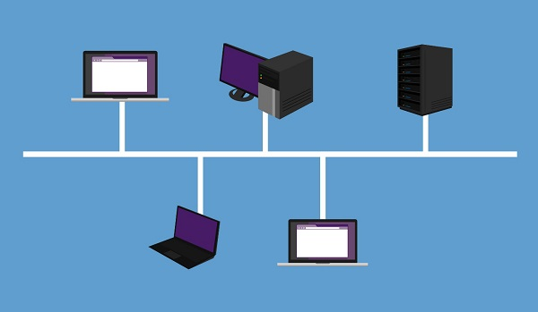

The data travels in both the directions along the bus. When the destination terminal sees the data, it copies it to the local disk.

### **Advantages of Bus Topology**

These are the advantages of using bus topology −

* Easy to install and maintain
* Can be extended easily
* Very reliable because of single transmission line

### **Disadvantages of Bus Topology**

These are some disadvantages of using bus topology −

* Troubleshooting is difficult as there is no single point of control
* One faulty node can bring the whole network down
* Dumb terminals cannot be connected to the bus

## ****Ring Topology****

In **ring topology** each terminal is connected to exactly **two nodes**, giving the network a circular shape. Data travels in only one predetermined direction.

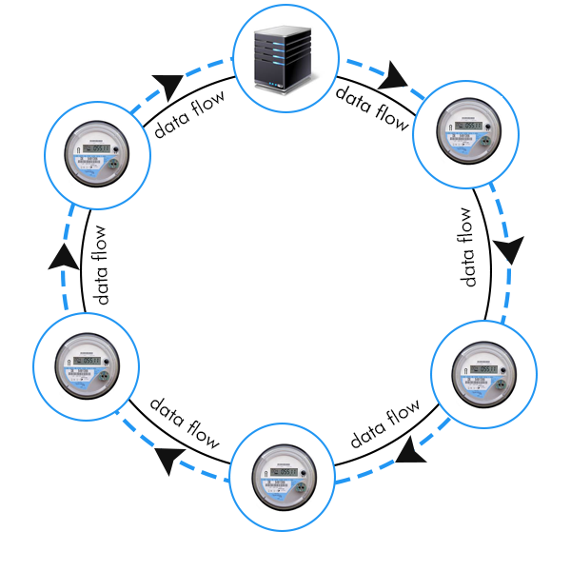

When a terminal has to send data, it transmits it to the neighboring node which transmits it to the next one. Before further transmission data may be amplified. In this way, data traverses the network and reaches the destination node, which removes it from the network. If the data reaches the sender, it removes the data and resends it later.

### **Advantages of Ring Topology**

These are the advantages of using ring topology −

* Small cable segments are needed to connect two nodes
* Ideal for optical fibres as data travels in only one direction
* Very high transmission speeds possible

### **Disadvantages of Ring Topology**

These are some the disadvantages of using ring topology −

* Failure of single node brings down the whole network
* Troubleshooting is difficult as many nodes may have to be inspected before faulty one is identified
* Difficult to remove one or more nodes while keeping the rest of the network intact

## Star Topology

In star topology, server is connected to each node individually. Server is also called the central node. Any exchange of data between two nodes must take place through the server. It is the most popular topology for information and voice networks as central node can process data received from source node before sending it to the destination node.

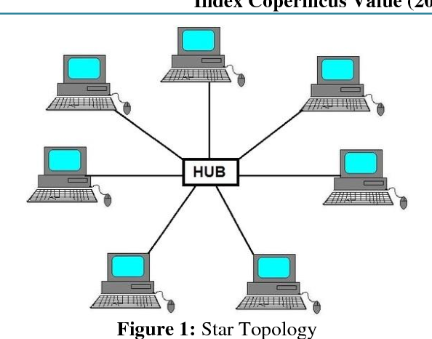

### **Advantages of Star Topology**

These are the advantages of using star topology −

* Failure of one node does not affect the network
* Troubleshooting is easy as faulty node can be detected from central node immediately
* Simple access protocols required as one of the communicating nodes is always the central node

### **Disadvantages of Star Topology**

These are the disadvantages of using star topology −

* Long cables may be required to connect each node to the server
* Failure of central node brings down the whole network

## Tree Topology

Tree topology has a group of star networks connected to a linear bus backbone cable. It incorporates features of both star and bus topologies. Tree topology is also called hierarchical topology.

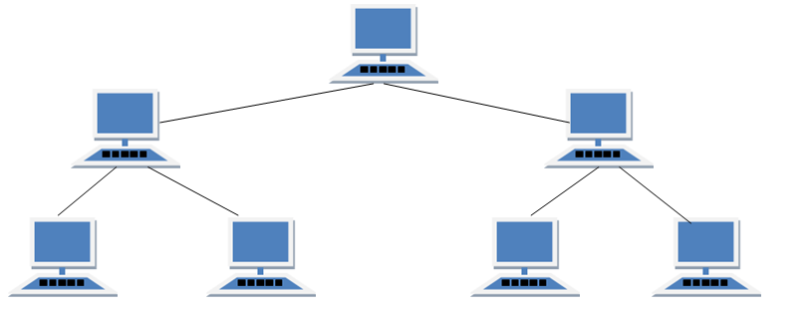

### **Advantages of Tree Topology**

These are some of the advantages of using tree topology −

* Existing network can be easily expanded
* Point-to-point wiring for individual segments means easier installation and maintenance
* Well suited for temporary networks

### **Disadvantages of Tree Topology**

These are some of the disadvantages of using tree topology −

* + Technical expertise required to configure and wire tree topology
  + Failure of backbone cable brings down entire network
  + Insecure network
  + Maintenance difficult for large networks

## Mesh Topology

In this type of topology, a host is connected to one or multiple hosts.This topology has hosts in point-to-point connection with every other host or may also have hosts which are in point-to-point connection to few hosts only.

## Full Mesh Topology

Hosts in Mesh topology also work as relay for other hosts which do not have direct point-to-point links. Mesh technology comes into two types:

* **Full Mesh**: All hosts have a point-to-point connection to every other host in the network. Thus for every new host n(n-1)/2 connections are required. It provides the most reliable network structure among all network topologies.
* **Partially Mesh**: Not all hosts have point-to-point connection to every other host. Hosts connect to each other in some arbitrarily fashion. This topology exists where we need to provide reliability to some hosts out of all.

## ****Hybrid Network Topology****

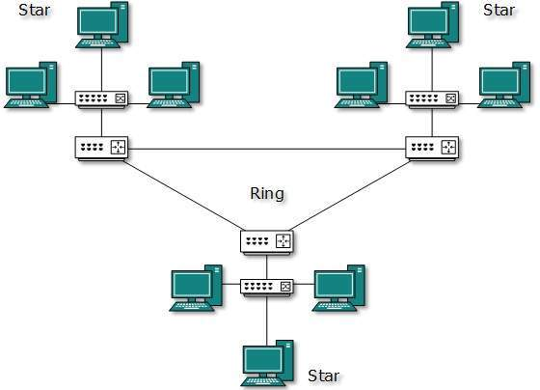A network structure whose design contains more than one topology is said to be hybrid topology. Hybrid topology inherits merits and demerits of all the incorporating topologies. It usually used to connect the different floors or rooms of a building.

Data Communication Hardware

Data communications refers to the transmission of this digital data between two or more computers and a computer network or data network is a telecommunications network that allows computers to exchange data. The physical connection between networked computing devices is established using either cable media or wireless media.

**Network Devices**

Hardware devices that are used to connect computers, printers, fax machines and other electronic devices to a network are called **network devices**. These devices transfer data in a fast, secure and correct way over same or different networks. Network devices may be inter-network or intra-network. Some devices are installed on the device, like NIC card or RJ45 connector, whereas some are part of the network, like router, switch, etc. Let us explore some of these devices in greater detail.

## Modem

Modem is a device that enables a computer to send or receive data over telephone or cable lines. The data stored on the computer is digital whereas a telephone line or cable wire can transmit only analog data.

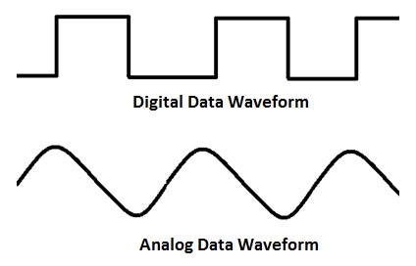

The main function of the modem is to convert digital signal into analog and vice versa. Modem is a combination of two devices − **modulator** and **demodulator**. The **modulator** converts digital data into analog data when the data is being sent by the computer. The **demodulator** converts analog data signals into digital data when it is being received by the computer.

## Types of Modem

Modem can be categorized in several ways like direction in which it can transmit data, type of connection to the transmission line, transmission mode, etc.

Depending on direction of data transmission, modem can be of these types −

* **Simplex** − A simplex modem can transfer data in only one direction, from digital device to network (modulator) or network to digital device (demodulator).
* **Half duplex** − A half-duplex modem has the capacity to transfer data in both the directions but only one at a time.
* **Full duplex** − A full duplex modem can transmit data in both the directions simultaneously.

## RJ45 Connector

RJ45 is the acronym for **Registered Jack 45. RJ45 connector** is an 8-pin jack used by devices to physically connect to **Ethernet** based **local area networks (LANs)**. **Ethernet** is a technology that defines protocols for establishing a LAN. The cable used for Ethernet LANs are twisted pair ones and have **RJ45 connector pins** at both ends. These pins go into the corresponding socket on devices and connect the device to the network.

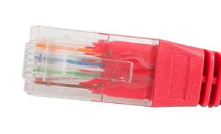

## Ethernet Card

**Ethernet card**, also known as **network interface card (NIC)**, is a hardware component used by computers to connect to **Ethernet LAN** and communicate with other devices on the LAN. The earliest **Ethernet cards** were external to the system and needed to be installed manually. In modern computer systems, it is an internal hardware component. The NIC has **RJ45 socket** where network cable is physically plugged in.

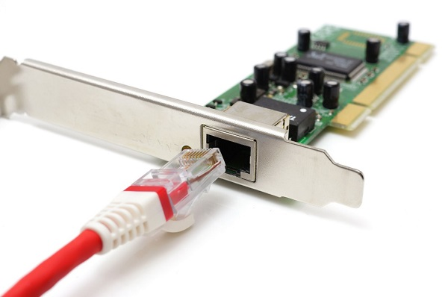

**Ethernet card speeds** may vary depending upon the protocols it supports. Old Ethernet cards had maximum speed of **10 Mbps**. However, modern cards support fast Ethernets up to a speed of **100 Mbps**. Some cards even have capacity of **1 Gbps**.

## Router

A **router** is a **network layer** hardware device that transmits data from one LAN to another if both networks support the same set of protocols. So a **router** is typically connected to at least two LANs and the **internet service provider** (ISP). It receives its data in the form of **packets**, which are **data frames** with their **destination address** added. Router also strengthens the signals before transmitting them. That is why it is also called **repeater**.

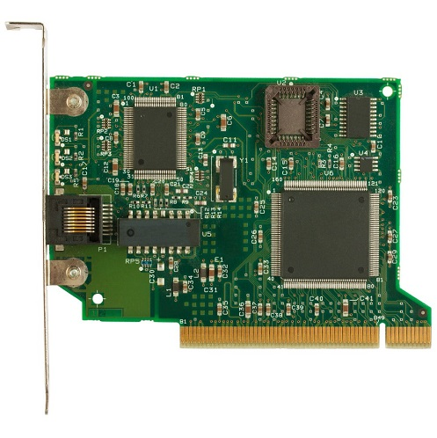

## Routing Table

A router reads its routing table to decide the best available route the packet can take to reach its destination quickly and accurately. The routing table may be of these two types −

* **Static** − In a static routing table the routes are fed manually. So it is suitable only for very small networks that have maximum two to three routers.
* **Dynamic** − In a dynamic routing table, the router communicates with other routers through protocols to determine which routes are free. This is suited for larger networks where manual feeding may not be feasible due to large number of routers.

## Switch

**Switch** is a network device that connects other devices to **Ethernet** networks through **twisted pair** cables. It uses **packet switching** technique to **receive, store** and **forward data packets** on the network. The switch maintains a list of network addresses of all the devices connected to it.

On receiving a packet, it checks the destination address and transmits the packet to the correct port. Before forwarding, the packets are checked for collision and other network errors. The data is transmitted in full duplex mode

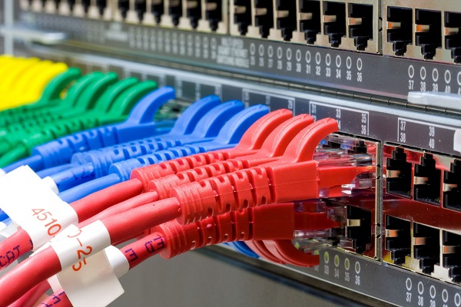

Data transmission speed in switches can be double that of other network devices like hubs used for networking. This is because switch shares its maximum speed with all the devices connected to it. This helps in maintaining network speed even during high traffic. In fact, higher data speeds are achieved on networks through use of multiple switches.

## Gateway

**Gateway** is a network device used to connect two or more dissimilar networks. In networking parlance, networks that use different protocols are **dissimilar networks**. A gateway usually is a computer with multiple **NICs** connected to different networks. A gateway can also be configured completely using software. As networks connect to a different network through gateways, these gateways are usually hosts or end points of the network.

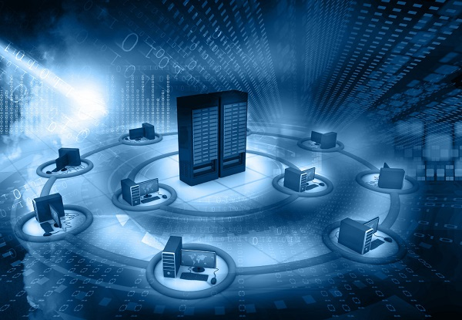

**Gateway** uses **packet switching** technique to transmit data from one network to another. In this way it is similar to a **router**, the only difference being router can transmit data only over networks that use same protocols.

## Wi-Fi Card

**Wi-Fi** is the acronym for **wireless fidelity. Wi-Fi technology** is used to achieve **wireless connection** to any network. **Wi-Fi card** is a **card** used to connect any device to the local network wirelessly. The physical area of the network which provides internet access through Wi-Fi is called **Wi-Fi hotspot**. Hotspots can be set up at home, office or any public space. Hotspots themselves are connected to the network through wires.

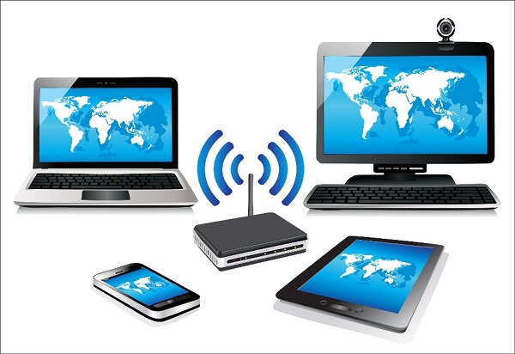

A **Wi-fi card** is used to add capabilities like **teleconferencing, downloading** digital camera images, **video chat**, etc. to old devices. Modern devices come with their in-built **wireless network adapter**.

pam is a common way to spread viruses, trojans, and the like.

### **Network Protocols**

Network Protocols are a set of rules governing exchange of information in an easy, reliable and secure way. Before we discuss the most common protocols used to transmit and receive data over a network, we need to understand how a network is logically organized or designed. The most popular model used to establish open communication between two systems is the Open Systems Interface (OSI) model proposed by ISO.

**Ethernet**

one of the most widely used network protocol

* It is simple and inexpensive to use
* It makes use of the linear bus topology

.

**Token Ring**

* an IBM network Protocols which is based on the ring topology.
* token ring network transmit the electronic address of each node on the network many times per second.

## ****ARCNET****

is based on the star or distributed star topology, but it has a topology and protocol of its own.

### **Internet**

Internet is defined as an Information super Highway, to access information over the web. However, it can be defined in many ways as follows:

* Internet is a world-wide global system of interconnected computer networks.
* Internet uses the standard Internet Protocol (TCP/IP).
* Every computer in internet is identified by a unique IP address.
* IP Address is a unique set of numbers (such as 110.22.33.114) which identifies a computer location.
* A special computer DNS (Domain Name Server) is used to give name to the IP Address so that user can locate a computer by a name.
* For example, a DNS server will resolve a name [**http://www.tip.edu.ph (Links to an external site.)**](http://www.tip.edu.ph/)to a particular IP address to uniquely identify the computer on which this website is hosted.
* Internet is accessible to every user all over the world.

### **Evolution**

The concept of Internet was originated in 1969 and has undergone several technological & Infrastructural changes as discussed below:

* + - The origin of Internet devised from the concept of **Advanced Research Project Agency Network (ARPANET).**
    - **ARPANET**was developed by United States Department of Defense.
    - Basic purpose of ARPANET was to provide communication among the various bodies of government.
    - Initially, there were only four nodes, formally called
    - In 1972, the **ARPANET**spread over the globe with 23 nodes located at different countries and thus became known as
    - By the time, with invention of new technologies such as TCP/IP protocols, DNS, WWW, browsers, scripting languages etc., Internet provided a medium to publish and access information over the web.

**Advantages of Internet**

Internet covers almost every aspect of life; one can think of. Here, we will discuss some of the advantages of Internet:

* Internet allows us to communicate with the people sitting at remote locations. There are various apps available on the wed that uses Internet as a medium for communication. One can find various social networking sites such as:
  + Facebook
  + Twitter
  + Yahoo
  + Google+
  + Flickr
  + Orkut
* One can surf for any kind of information over the internet. Information regarding various topics such as Technology, Health & Science, Social Studies, Geographical Information, Information Technology, Products etc can be surfed with help of a search engine.
* Apart from communication and source of information, internet also serves a medium for entertainment. Following are the various modes for entertainment over internet.
  + Online Television
  + Online Games
  + Songs
  + Videos
  + Social Networking Apps
* Internet allows us to use many services like:
  + Internet Banking
  + Matrimonial Services
  + Online Shopping
  + Online Ticket Booking
  + Online Bill Payment
  + Data Sharing
  + E-mail
* Internet provides concept of **electronic commerce**, that allows the business deals to be conducted on electronic systems

### **Disadvantages of Internet**

However, Internet has proved to be a powerful source of information in almost every field, yet there exist many disadvantages discussed below:

* There are always chances to lose personal information such as name, address, credit card number. Therefore, one should be very careful while sharing such information. One should use credit cards only through authenticated sites.
* Another disadvantage is the **Spamming**. Spamming corresponds to the unwanted e-mails in bulk. These e-mails serve no purpose and lead to obstruction of entire system.
* **Virus**can easily be spread to the computers connected to internet. Such virus attacks may cause your system to crash or your important data may get deleted.
* Also, a biggest threat on internet is pornography. There are many pornographic sites that can be found, letting your children to use internet which indirectly affects the children healthy mental life.
* There are various websites that do not provide the authenticated information. This leads to misconception among many people.

## Intranet

Intranet is defined as private network of computers within an organization with its own server and firewall. Moreover, we can define Intranet as:

* + Intranet is system in which multiple PCs are networked to be connected to each other. PCs in intranet are not available to the world outside of the intranet.
  + Usually each company or organization has their own Intranet network and members/employees of that company can access the computers in their intranet.
  + Every computer in internet is identified by a unique IP address.
  + Each computer in Intranet is also identified by an IP Address, which is unique among the computers in that Intranet.

## Benefits

Intranet is very efficient and reliable network system for any organization. It is beneficial in every aspect such as collaboration, cost-effectiveness, security, productivity and much more.

### **Communication**

Intranet offers easy and cheap communication within an organization. Employees can communicate using chat, e-mail or blogs.

### **Time Saving**

Information on Intranet is shared in real time.

### **Collaboration**

Information is distributed among the employees as according to requirement and it can be accessed by the authorized users, resulting in enhanced teamwork.

### **Platform Independency**

Intranet can connect computers and other devices with different architecture.

### **Cost Effective**

Employees can see the data and other documents using browser rather than printing them and distributing duplicate copies among the employees, which certainly decreases the cost.

### **Workforce Productivity**

Data is available at every time and can be accessed using company workstation. This helps the employees work faster.

### **Business Management**

It is also possible to deploy applications that support business operations.

### **Security**

Since information shared on intranet can only be accessed within an organization, therefore there is almost no chance of being theft.

### **Specific Users**

Intranet targets only specific users within an organization therefore, once can exactly know whom he is interacting.

### **Immediate Updates**

Any changes made to information are reflected immediately to all the users.

## Issues

Apart from several benefits of Intranet, there also exist some issues.. These issues are shown in the following diagram:

## ****Management Concerns****

Lost of control

Hidden complexity

Potential for chaos

**Security Concerns**

Unauthorized access

Denial for service

Packet Sniffing

## Productivity Concerns

Information overload lowers productivity

Users set up own we pages

Overabundance of information

## Applications

Intranet applications are same as that of Internet applications. Intranet applications are also accessed through a web browser. The only difference is that, Intranet applications reside on local server while Internet applications reside on remote server. Here, we've discussed some of these applications:

### **Document publication applications**

Document publication applications allow publishing documents such as manuals, software guide, employee profits etc. without use of paper.

### **Electronic resources applications**

It offers electronic resources such as software applications, templates and tools, to be shared across the network.

### **Interactive Communication applications**

Like on internet, we have email and chat like applications for Intranet, hence offering an interactive communication among employees.

### **Support for Internet Applications**

Intranet offers an environment to deploy and test applications before placing them on Internet.

## Internet vs. Intranet

Apart from similarities there are some differences between the two. Following are the differences between Internet and Intranet:

|  |  |
| --- | --- |
| **Intranet** | **Internet** |
| Localized Network. | Worldwide Network |
| Doesn't have access to Intranet | Have access to Internet. |
| More Expensive | Less Expensive |
| Safer | Less Safe |
| More Reliability | Less Reliability |

## Extranet

Extranet refers to network within an organization, using internet to connect to the outsiders in controlled manner. It helps to connect businesses with their customers and suppliers and therefore allows working in a collaborative manner.

### **Implementation**

Extranet is implemented as a Virtual Private Networks (VPN) because it uses internet to connect to corporate organization and there is always a threat to information security. VPN offers a secure network in public infrastructure (Internet).

**Key Points**

* + - The packet is encapsulated at boundary of networks in IPSEC complaint routers.
    - It uses an encryption key to encapsulate packets and IP addresses as well.
    - The packet is decoded only by the IPSEC complaint routers or servers.
    - The message is sent over VPN via VPN Tunnel and this process is known as tunneling.

VPN uses **Internet Protocol Security Architecture (IPSEC)** Protocol to provide secure transactions by adding an additional security layer to TCP/IP protocol.

## Benefits

Extranet proves to be a successful model for all kind of businesses whether small or big. Here are some of the advantages of extranet for employees, suppliers, business partners, and customers:

## Issues

Apart for advantages there are also some issues associated with extranet. These issues are discussed below:

### **Hosting**

Where the extranet pages will be held i.e. who will host the extranet pages. In this context there are two choices:

* + - * + Host it on your own server.
        + Host it with an Internet Service Provider (ISP) in the same way as web pages.

But hosting extranet pages on your own server requires high bandwidth internet connection which is very costly.

### **Security**

Additional firewall security is required if you host extranet pages on your own server which result in a complex security mechanism and increase workload.

### **Accessing Issues**

Information cannot be accessed without internet connection. However, information can be accessed in Intranet without internet connection.

### **Decreased Interaction**

It decreases the face to face interaction in the business which results in lack of communication among customers, business partners and suppliers.

## Extranet vs. Intranet

An **intranet** is a private network, operated by a large company or other organisation, which uses internet technologies, but is insulated from the global internet. An **extranet** is an **intranet** that is accessible to some people from outside the company, or possibly shared by more than one organisation.

The following table shows differences between Extranet and Intranet:

|  |  |
| --- | --- |
| **Extranet** | **Intranet** |
| Internal network that can be accessed externally. | Internal network that cannot be accessed externally. |
| Extranet is extension of company's Intranet. | Only limited users of a company. |
| For limited external communication between customers, suppliers and business partners. | Only for communication within a company. |

## Dns icon vector****Domain Name System****

When **DNS** was not into existence, one had to download a **Host file** containing host names and their corresponding IP address. But with increase in number of hosts of internet, the size of host file also increased. This resulted in increased traffic on downloading this file. To solve this problem the DNS system was introduced.

**Domain Name System** helps to resolve the host name to an address. It uses a hierarchical naming scheme and distributed database of IP addresses and associated names

## IP Address

IP address is a unique logical address assigned to a machine over the network. An IP address exhibits the following properties:

* IP address is the unique address assigned to each host present on Internet.
* IP address is 32 bits (4 bytes) long.
* IP address consists of two components:**network component** and **host component**.
* Each of the 4 bytes is represented by a number from 0 to 255, separated with dots. For example, 137.170.4.124

IP address is 32-bit number while on the other hand domain names are easy to remember names. For example, when we enter an email address, we always enter a symbolic string such as webmaster@tutorialspoint.com.

## Uniform Resource Locator (URL)

**Uniform Resource Locator (URL)** refers to a web address which uniquely identifies a document over the internet.

This document can be a web page, image, audio, video or anything else present on the web.

For example, [**www.tip.edu.ph/index.html (Links to an external site.)**](https://www.tip.edu.ph/index.html)  is an URL to the index.html which is stored on **tip** web server under **course** directory.

### **URL Types**

There are two forms of URL as listed below:

* + - Absolute URL
    - Relative URL

### **Absolute URL**

Absolute URL is a complete address of a resource on the web. This completed address comprises of protocol used, server name, path name and file name.

For example, [**https://www.tip.edu.ph/index.html (Links to an external site.)**](https://www.tip.edu.ph/index.html) where:

**http**is the protocol.

[**tip.edu.ph (Links to an external site.)**](https://www.tip.edu.ph/index.html) is the server name.

**index.htm** is the file name.

The protocol part tells the web browser how to handle the file. Similarly, we have some other protocols also that can be used to create URL are:

FTP

https

Gopher

mailto

news

### **Relative URL**

Relative URL is a partial address of a webpage. Unlike absolute URL, the protocol and server part are omitted from relative URL.

Relative URLs are used for internal links i.e. to create links to file that are part of same website as the Web Pages on which you are placing the link.

For example, to link an image on tutorialspoint.com/internet\_technology/internet\_referemce\_models, we can use the relative URL which can take the form like **/internet\_technologies/internet-osi\_model.jpg.**

### **Difference between Absolute and Relative URL**

|  |  |
| --- | --- |
| **Absolute URL** | **Relative URL** |
| Used to link web pages on different websites | Used to link web pages within the same website. |
| Difficult to manage. | Easy to Manage |
| Changes when the server name or directory name changes | Remains same even of we change the server name or directory name. |
| Take time to access | Comparatively faster to access. |

## Domain Name System Architecture

The Domain name system comprises of **Domain Names, Domain Name Space, Name Server** that have been described below:

### **Domain Names**

Domain Name is a symbolic string associated with an IP address. There are several domain names available; some of them are generic such as **com, edu, gov, net** etc, while some country level domain names such as **au, in, za, us** etc.

The following table shows the **Generic** Top-Level Domain names:

|  |
| --- |
|  |
| **Domain Name** | **Meaning** |
| com | Commercial business |
| edu | Education |
| gov | U.S. government agency |
| int | International entity |
| mil | U.S. military |
| net | Networking organization |
| org | Non profit organization |

The following table shows the **Country top-level** domain names:

|  |
| --- |
|  |
| **Domain Name** | **Meaning** |
| au | Australia |
| in | India |
| cl | Chile |
| fr | France |
| us | United States |
| za | South Africa |
| uk | United Kingdom |
| jp | Japan |
| es | Spain |
| de | Germany |
| ca | Canada |
| ee | Estonia |
| hk | Hong Kong |

### **Domain Name Space**What is a Domain Namespace?

The domain name space refers a hierarchy in the internet naming structure. This hierarchy has multiple levels (from 0 to 127), with a root at the top. The following diagram shows the domain name space hierarchy:

In the diagram each subtree represents a domain. Each domain can be partitioned into sub domains and these can be further partitioned and so on.

### **Name Server**

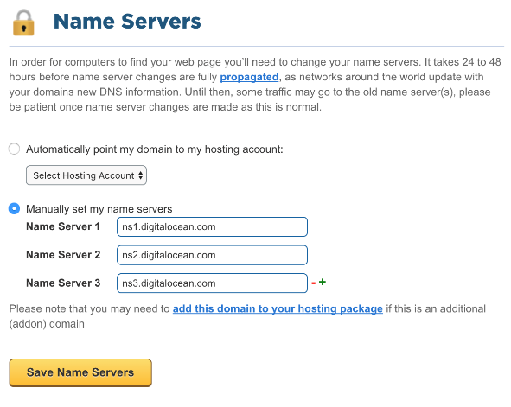

Name server contains the DNS database. This database comprises of various names and their corresponding IP addresses. Since it is not possible for a single server to maintain entire DNS database, therefore, the information is distributed among many DNS servers.

* Hierarchy of server is same as hierarchy of names.
* The entire name space is divided into the zones

### **Zones**

Zone is collection of nodes (sub domains) under the main domain. The server maintains a database called zone file for every zone.

If the domain is not further divided into sub domains then domain and zone refers to the same thing.

The information about the nodes in the sub domain is stored in the servers at the lower levels however; the original server keeps reference to these lower levels of servers.

#### **Types of Name Servers**Figure 2.9

Following are the three categories of Name Servers that manages the entire Domain Name System:

##### **Root Server**

Root Server is the top-level server which consists of the entire DNS tree. It does not contain the information about domains but delegates the authority to the other server

##### **Primary Servers**

Primary Server stores a file about its zone. It has authority to create, maintain, and update the zone file.

##### **Secondary Server**

Secondary Server transfers complete information about a zone from another server which may be primary or secondary server. The secondary server does not have authority to create or update a zone file.

## DNS Working

DNS translates the domain name into IP address automatically. Following steps will take you through the steps included in domain resolution process:

* When we type **tip.edu.ph**into the browser, it asks the local DNS Server for its IP address.

Here the local DNS is at ISP end.

* When the local DNS does not find the IP address of requested domain name, it forwards the request to the root DNS server and again enquires about IP address of it.
* The root DNS server replies with delegation that **I do not know the IP address of www.tip.edu.ph but know the IP address of DNS Server.**
* The local DNS server then asks the com DNS Server the same question.
* The **edu**DNS Server replies the same that it does not know the IP address of www.tip.edu but knows the address of **edu.ph.** Then the local DNS asks the **tip.edu.ph** DNS server the same question.
* Then tip.edu DNS server replies with IP address of **tip.edu.ph**
* Now, the local DNS sends the IP address of **tip.edu.ph** to the computer that sends the request.
* **Internet Services**allows us to access huge amount of information such as text, graphics, sound and software over the internet. Following diagram shows the four different categories of Internet Services.

## Communication Services

* There are various Communication Services available that offer exchange of information with individuals or groups.

* The following table gives a brief introduction to these services:

|  |
| --- |
| **Service Description** |
| **Electronic Mail** Used to send electronic message over the internet. |
| **Telnet** Used to log on to a remote computer that is attached to internet. |
| **Newsgroup** Offers a forum for people to discuss topics of common interests. |
| **Internet Relay Chat (IRC)** Allows the people from all over the world to communicate in real time. |
| **Mailing Lists** Used to organize group of internet users to share common information through e-mail. |
| **Internet Telephony (VoIP)** Allows the internet users to talk across internet to any PC equipped to receive the call. |
| **Instant Messaging** Offers real time chat between individuals and group of people. Eg. Yahoo messenger, MSN messenger. |

## Information Retrieval Services

* The following table gives a brief introduction to these services:

There exist several Information retrieval services offering easy access to information present on the interne

|  |
| --- |
| **Service Description** |
| **File Transfer Protocol (FTP)** Enable the users to transfer files. |
| **Archie** It’s updated database of public FTP sites and their content. It helps to search a file by its name. |
| **Gopher** Used to search, retrieve, and display documents on remote sites. |
| **Very Easy Rodent Oriented Netwide Index to Computer Achieved (VERONICA)** VERONICA is gopher-based resource. It allows access to the information resource stored on gopher’s servers. |

## Web Services

* + Web services allow exchange of information between applications on the web. Using web services, applications can easily interact with each other.
  + The web services are offered using concept of **Utility Computing.**

## World Wide Web (WWW)

WWW is also known as W3. It offers a way to access documents spread over the several servers over the internet. These documents may contain texts, graphics, audio, video, hyperlinks. The hyperlinks allow the users to navigate between the documents.

## Video Conferencing

Video conferencing or Video teleconferencing is a method of communicating by two-way video and audio transmission with help of telecommunication technologies.

### **Modes of Video Conferencing**

#### **Point-to-Point**

* This mode of conferencing connects two locations only.

#### **Multi-point**

* This mode of conferencing connects more than two locations through **Multi-point Control Unit (MCU).**

## Internet Service Providers (ISP)

**Internet Service Provider (ISP)** is a company offering access to internet. They offer various services:

* Internet Access
* Domain name registration
* Dial-up access
* Leased line access

### **ISP Types**

ISPs can broadly be classified into six categories as shown in the following diagram:

#### **Access providers**

They provide access to internet through telephone lines, cable wi-fi or fiber optics.

#### **Mailbox Provider**

Such providers offer mailbox hosting services.

#### **Hosting ISPs**

Hosting ISPs offers e-mail, and other web hosting services such as virtual machines, clouds etc.

#### **Virtual ISPs**

Such ISPs offer internet access via other ISP services.

#### **Free ISPs**

Free ISPs do not charge for internet services.

## Connection Types

There exist several ways to connect to the internet. Following are these connection types available:

### **Dial-up Connection**Dial-Up Line – Network Encyclopedia

**Dial-up** connection uses telephone line to connect PC to the internet. It requires a modem to setup dial-up connection. This modem works as an interface between PC and the telephone line.

There is also a communication program that instructs the modem to make a call to specific number provided by an ISP.

Dial-up connection uses either of the following protocols:

* + 1. Serial Line Internet Protocol (SLIP)
    2. Point to Point Protocol (PPP)

The following diagram shows the accessing internet using modem:

### **ISDN**

**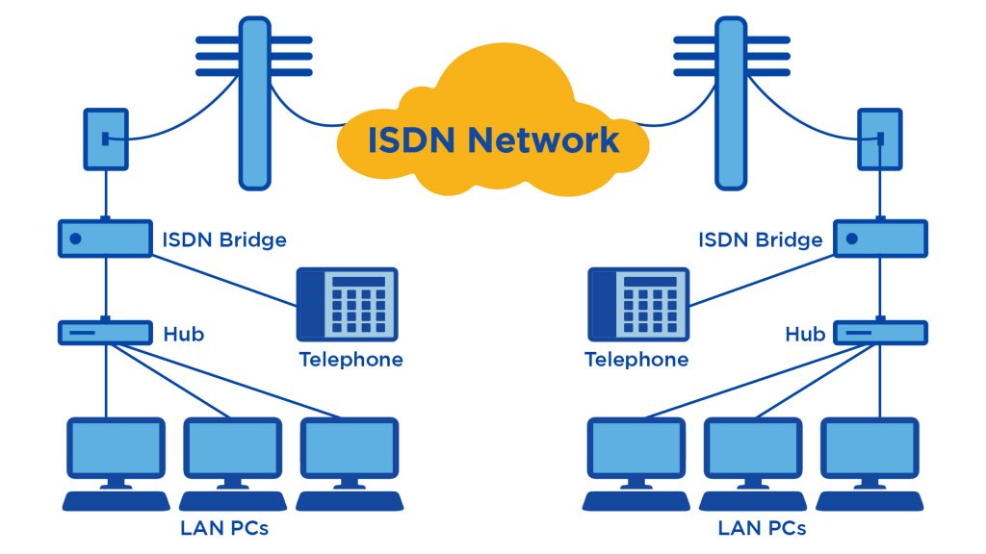ISDN** is acronym of **Integrated Services Digital Network.** It establishes the connection using the phone lines which carry digital signals instead of analog signals.

There are two techniques to deliver ISDN services:

* + 1. Basic Rate Interface (BRI)
    2. Primary Rate Interface (PRI)

**Key points:**

* + - The BRI ISDN consists of three distinct channels on a single ISDN line: t1o 64kbps B (Bearer) channel and one 16kbps D (Delta or Data) channels.
    - The PRI ISDN consists of 23 B channels and one D channels with both have operating capacity of 64kbps individually making a total transmission rate of 1.54Mbps.

The following diagram shows accessing internet using ISDN connection:

### **DSL**

**DSL** is acronym of **Digital Subscriber Line.** It is a form of broadband connection as it provides connection over ordinary telephone lines.

Following are the several versions of DSL technique available today:

* + 1. Asymmetric DSL (ADSL)
    2. Symmetric DSL (SDSL)
    3. High bit-rate DSL (HDSL)
    4. Rate adaptive DSL (RDSL)
    5. Very high bit-rate DSL (VDSL)
    6. ISDN DSL (IDSL)

All of the above-mentioned technologies differ in their upload and download speed, bit transfer rate and level of service.

The following diagram shows that how we can connect to internet using DSL technology:

### **Cable TV Internet Connection**

Cable TV Internet connection is provided through Cable TV lines. It uses coaxial cable which is capable of transferring data at much higher speed than common telephone line.

**Key Points:**

* + - A cable modem is used to access this service, provided by the cable operator.
    - The Cable modem comprises of two connections: one for internet service and other for Cable TV signals.
    - Since Cable TV internet connections share a set amount of bandwidth with a group of customers, therefore, data transfer rate also depends on number of customers using the internet at the same time.

The following diagram shows that how internet is accessed using Cable TV connection:

### **Satellite Internet Connection**

Satellite Internet connection offers high speed connection to the internet. There are two types of satellite internet connection: one-way connection or two-way connection.

In one-way connection, we can only download data but if we want to upload, we need a dialup access through ISP over telephone line.

In two-way connection, we can download and upload the data by the satellite. It does not require any dialup connection.

The following diagram shows how internet is accessed using satellite internet connection:

### **Wireless Internet Connection**

Wireless Internet Connection makes use of radio frequency bands to connect to the internet and offers a very high speed. The wireless internet connection can be obtained by either WIFI or Bluetooth.

**Key Points:**

* + - * Wi Fi wireless technology is based on IEEE 802.11 standards which allow the electronic device to connect to the internet.
      * Bluetooth wireless technology makes use of short-wavelength radio waves and helps to create personal area network (PAN).

## Transmission Control Protocol (TCP)

**Transmission Control Protocol (TCP):** TCP is a popular communication protocol which is used for communicating over a network. It divides any message into series of packets that are sent from source to destination and there it gets reassembled at the destination.

TCP is a connection oriented protocol and offers end-to-end packet delivery. It acts as back bone for connection. It exhibits the following key features:

* Transmission Control Protocol (TCP) corresponds to the Transport Layer of OSI Model.
* TCP is a reliable and connection oriented protocol.
* TCP offers:
  + Stream Data Transfer.
  + Reliability.
  + Efficient Flow Control
  + Full-duplex operation.
  + Multiplexing.
* TCP offers connection oriented end-to-end packet delivery.
* TCP ensures reliability by sequencing bytes with a forwarding acknowledgement number that indicates to the destination the next byte the source expect to receive.
* It retransmits the bytes not acknowledged with in specified time period.

## TCP Services

TCP offers following services to the processes at the application layer:

* Stream Delivery Service
* Sending and Receiving Buffers
* Bytes and Segments
* Full Duplex Service
* Connection Oriented Service
* Reliable Service

#### **Stream Deliver Service**

TCP protocol is stream oriented because it allows the sending process to send data as stream of bytes and the receiving process to obtain data as stream of bytes.

#### **Sending and Receiving Buffers**

It may not be possible for sending and receiving process to produce and obtain data at same speed, therefore, TCP needs buffers for storage at sending and receiving ends.

#### **Bytes and Segments**

The Transmission Control Protocol (TCP), at transport layer groups the bytes into a packet. This packet is called segment. Before transmission of these packets, these segments are encapsulated into an IP datagram.

#### **Full Duplex Service**

Transmitting the data in duplex mode means flow of data in both the directions at the same time.

#### **Connection Oriented Service**

TCP offers connection oriented service in the following manner:

1. TCP of process-1 informs TCP of process – 2 and gets its approval.
2. TCP of process – 1 and TCP of process – 2 and exchange data in both the two directions.
3. After completing the data exchange, when buffers on both sides are empty, the two TCP’s destroy their buffers.

#### **Reliable Service**

For sake of reliability, TCP uses acknowledgement mechanism.

## Internet Protocol (IP)

**Internet Protocol (IP):**IP is designed explicitly as addressing protocol. It is mostly used with TCP. The IP addresses in packets help in routing them through different nodes in a network until it reaches the destination system. TCP/IP is the most popular protocol connecting the networks.

Internet Protocol is **connectionless** and **unreliable** protocol. It ensures no guarantee of successfully transmission of data.

In order to make it reliable, it must be paired with reliable protocol such as TCP at the transport layer.

Internet protocol transmits the data in form of a datagram as shown in the following diagram:

### **internet_technologies_tutorial**

**Points to remember:**

* The length of datagram is variable.
* The Datagram is divided into two parts: **header** and **data.**
* The length of header is 20 to 60 bytes.
* The header contains information for routing and delivery of the packet.

## User Datagram Protocol (UDP)

**User Datagram Protocol (UDP):**UDP is a substitute communication protocol to Transmission Control Protocol implemented primarily for creating loss-tolerating and low-latency linking between different applications.

Like IP, UDP is connectionless and unreliable protocol. It doesn’t require making a connection with the host to exchange data. Since UDP is unreliable protocol, there is no mechanism for ensuring that data sent is received.

UDP transmits the data in form of a datagram. The UDP datagram consists of five parts as shown in the following diagram:

* + Source Port
  + Destination Portta
  + Length
  + UDP checksum
  + Data

**Points to remember:**

* UDP is used by the application that typically transmit small amount of data at one time.
* UDP provides protocol port used i.e. UDP message contains both source and destination port number, that makes it possible for UDP software at the destination to deliver the message to correct application program.

## File Transfer Protocol (FTP)

**File Transfer Protocol (FTP):**FTP allows users to transfer files from one machine to another. Types of files may include program files, multimedia files, text files, and documents, etc.

FTP is used to copy files from one host to another. FTP offers the mechanism for the same in following manner:

### 

* FTP creates two processes such as Control Process and Data Transfer Process at both ends i.e. at client as well as at server.
* FTP establishes two different connections: one is for data transfer and other is for control information.
* **Control connection** is made between **control processes** while **Data Connection** is made between
* FTP uses **port 21** for the control connection and **Port 20** for the data connection.

## Trivial File Transfer Protocol (TFTP)

**Trivial File Transfer Protocol** is also used to transfer the files but it transfers the files without authentication. Unlike FTP, TFTP does not separate control and data information. Since there is no authentication exists, TFTP lacks in security features therefore it is not recommended to use TFTP.

**Key points**

* TFTP makes use of UDP for data transport. Each TFTP message is carried in separate UDP datagram.
* The first two bytes of a TFTP message specify the type of message.
* The TFTP session is initiated when a TFTP client sends a request to upload or download a file.
* The request is sent from an ephemeral UDP port to the **UDP port 69**of an TFTP server.

## Difference between FTP and TFTP

|  |  |  |  |
| --- | --- | --- | --- |
|  | **Parameter** | **FTP** | **TFTP** |
|  | Operation | Transferring Files | Transferring Files |
|  | Authentication | Yes | No |
|  | Protocol | TCP | UDP |
|  | Ports | 21 – Control, 20 – Data | Port 3214, 69, 4012 |
|  | Control and Data | Separated | Separated |
|  | Data Transfer | Reliable | Unreliable |

### **Telnet**

Telnet is a protocol used to log in to remote computer on the internet. There are a number of Telnet clients having user friendly user interface. The following diagram shows a person is logged in to computer A, and from there, he remote logged into computer B.

### **internet_technologies_tutorial**

## Hyper Text Transfer Protocol (HTTP)

HTTP is a communication protocol. It defines mechanism for communication between browser and the web server. It is also called request and response protocol because the communication between browser and server takes place in request and response pairs.

### **HTTP Request**

HTTP request comprises of lines which contains:

* Request line
* Header Fields
* Message body

**Key Points**

* The first line i.e. the **Request line** specifies the request method i.e. **Get** or **Post.**
* The second line specifies the header which indicates the domain name of the server from where index.htm is retrieved.

### **HTTP Response**

Like HTTP request, HTTP response also has certain structure. HTTP response contains:

* Status line
* Headers
* Message body

### **E-Commerce or Electronics Commerce is a methodology of modern business, which addresses the need of business organizations, vendors and customers to reduce cost and improve the quality of goods and services while increasing the speed of delivery. Ecommerce refers to the paperless exchange of business information using the following ways −**

* Electronic Data Exchange (EDI)
* Electronic Mail (e-mail)
* Electronic Bulletin Boards
* Electronic Fund Transfer (EFT)
* Other Network-based technologies

### **e-commerce overview**

## Features

E-Commerce provides the following features −

* **Non-Cash Payment** − E-Commerce enables the use of credit cards, debit cards, smart cards, electronic fund transfer via bank's website, and other modes of electronics payment.
* **24x7 Service availability** − E-commerce automates the business of enterprises and the way they provide services to their customers. It is available anytime, anywhere.
* **Advertising / Marketing** − E-commerce increases the reach of advertising of products and services of businesses. It helps in better marketing management of products/services.
* **Improved Sales** − Using e-commerce, orders for the products can be generated anytime, anywhere without any human intervention. It gives a big boost to existing sales volumes.
* **Support** − E-commerce provides various ways to provide pre-sales and post-sales assistance to provide better services to customers.
* **Inventory Management** − E-commerce automates inventory management. Reports get generated instantly when required. Product inventory management becomes very efficient and easy to maintain.
* **Communication improvement** − E-commerce provides ways for faster, efficient, reliable communication with customers and partners.

## Traditional Commerce v/s E-Commerce

### **The Social Impact of e-Commerce On Society | Pros and Cons**

|  |  |  |
| --- | --- | --- |
| **Sr. No.** | **Traditional Commerce** | **E-Commerce** |
| 1 | Heavy dependency on information exchange from person to person. | Information sharing is made easy via electronic communication channels making little dependency on person to person information exchange. |
| 2 | Communication/ transaction are done in synchronous way. Manual intervention is required for each communication or transaction. | Communication or transaction can be done in asynchronous way. Electronics system automatically handles when to pass communication to required person or do the transactions. |
| 3 | It is difficult to establish and maintain standard practices in traditional commerce. | A uniform strategy can be easily established and maintain in e-commerce. |
| 4 | Communications of business depends upon individual skills. | In e-Commerce or Electronic Market, there is no human intervention. |
| 5 | Unavailability of a uniform platform as traditional commerce depends heavily on personal communication. | E-Commerce website provides user a platform where al l information is available at one place. |
| 6 | No uniform platform for information sharing as it depends heavily on personal communication. | E-Commerce provides a universal platform to support commercial / business activities across the globe. |

### **E-commerce business models**

E-commerce business models can generally be categorized into the following categories.

* Business - to - Business (B2B)
* Business - to - Consumer (B2C)
* Consumer - to - Consumer (C2C)
* Consumer - to - Business (C2B)
* Business - to - Government (B2G)
* Government - to - Business (G2B)
* Government - to - Citizen (G2C)

## Business - to - Business

A website following the B2B business model sells its products to an intermediate buyer who then sells the product to the final customer. As an example, a wholesaler places an order from a company's website and after receiving the consignment, sells the endproduct to the final customer who comes to buy the product at one of its retail outlets.

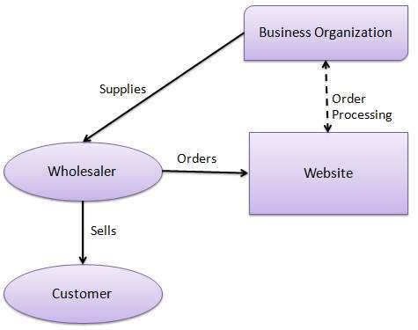

## Business - to - Consumer

A website following the B2C business model sells its products directly to a customer. A customer can view the products shown on the website. The customer can choose a product and order the same. The website will then send a notification to the business organization via email and the organization will dispatch the product/goods to the customer.

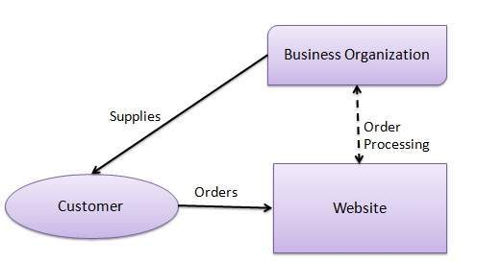

## Consumer - to - Consumer

A website following the C2C business model helps consumers to sell their assets like residential property, cars, motorcycles, etc., or rent a room by publishing their information on the website. Website may or may not charge the consumer for its services. Another consumer may opt to buy the product of the first customer by viewing the post/advertisement on the website.

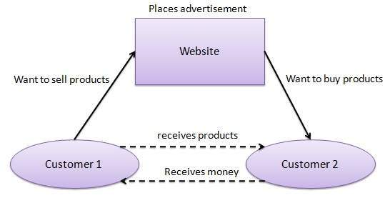

## Consumer - to - Business

In this model, a consumer approaches a website showing multiple business organizations for a particular service. The consumer places an estimate of amount he/she wants to spend for a particular service. For example, the comparison of interest rates of personal loan/car loan provided by various banks via websites. A business organization who fulfills the consumer's requirement within the specified budget, approaches the customer and provides its services.

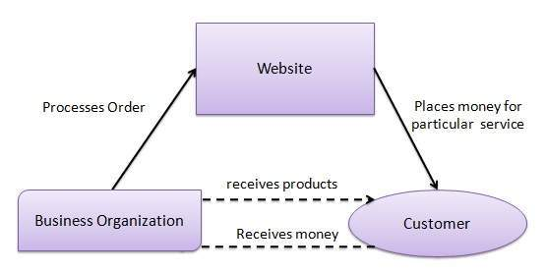

## Business - to - Government

B2G model is a variant of B2B model. Such websites are used by governments to trade and exchange information with various business organizations. Such websites are accredited by the government and provide a medium to businesses to submit application forms to the government.

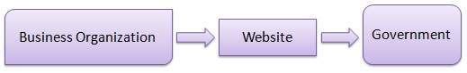

## Government - to - Business

Governments use B2G model websites to approach business organizations. Such websites support auctions, tenders, and application submission functionalities.

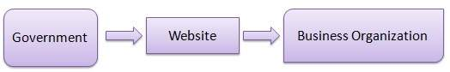

## Government - to - Citizen

Governments use G2C model websites to approach citizen in general. Such websites support auctions of vehicles, machinery, or any other material. Such website also provides services like registration for birth, marriage or death certificates. The main objective of G2C websites is to reduce the average time for fulfilling citizen’s requests for various government services.

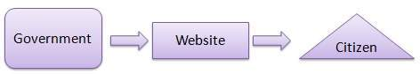-

### **Database**Get the Competitive Edge With The Latest Database Trends For 2020

### **is a collection of related data and data is a collection of facts and figures that can be processed to produce information.**

Mostly data represents recordable facts. Data aids in producing information, which is based on facts. For example, if we have data about marks obtained by all students, we can then conclude about toppers and average marks.

A **database management system** stores data in such a way that it becomes easier to retrieve, manipulate, and produce information.

### **Characteristics**

Traditionally, data was organized in file formats. DBMS was a new concept then, and all the research was done to make it overcome the deficiencies in traditional style of data management. A modern DBMS has the following characteristics −

* **Real-world entity**− A modern DBMS is more realistic and uses real-world entities to design its architecture. It uses the behavior and 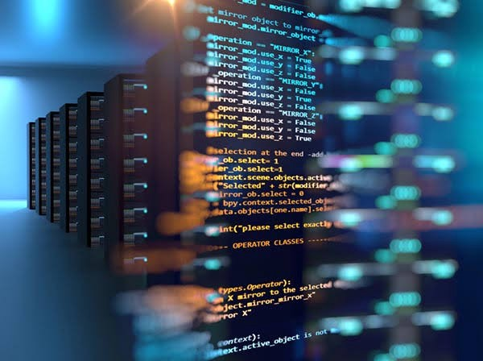attributes too. For example, a school database may use students as an entity and their age as an attribute.
* **Relation-based tables**− DBMS allows entities and relations among them to form tables. A user can understand the architecture of a database just by looking at the table names.
* **Isolation of data and application**− A database system is entirely different than its data. A database is an active entity, whereas data is said to be passive, on which the database works and organizes. DBMS also stores metadata, which is data about data, to ease its own process.
* **Less redundancy**− DBMS follows the rules of normalization, which splits a relation when any of its attributes is having redundancy in values. Normalization is a mathematically rich and scientific process that reduces data redundancy.

* **Consistency**− Consistency is a state where every relation in a database remains consistent. There exist methods and techniques, which can detect attempt of leaving database in inconsistent state. A DBMS can provide greater consistency as compared to earlier forms of data storing applications like file-processing systems.

* **Query Language**− DBMS is equipped with query language, which makes it more efficient to retrieve and manipulate data. A user can apply as many and as different filtering options as required to retrieve a set of data. Traditionally it was not possible where file-processing system was used.

* **ACID Properties**− DBMS follows the concepts of **A**tomicity, **C**onsistency, **I**solation, and **D**urability (normally shortened as ACID). These concepts are applied on transactions, which manipulate data in a database. ACID properties help the database stay healthy in multi-transactional environments and in case of failure.

* **Multiuser and Concurrent Access**− DBMS supports multi-user environment and allows them to access and manipulate data in parallel. Though there are restrictions on transactions when users attempt to handle the same data item, but users are always unaware of them.

* **Multiple views**− DBMS offers multiple views for different users. A user who is in the Sales department will have a different view of database than a person working in the Production department. This feature enables the users to have a concentrate view of the database according to their requirements.

* **Security**− Features like multiple views offer security to some extent where users are unable to access data of other users and departments. DBMS offers methods to impose constraints while entering data into the database and retrieving the same at a later stage. DBMS offers many different levels of security features, which enables multiple users to have different views with different features. For example, a user in the Sales department cannot see the data that belongs to the Purchase department. Additionally, it can also be managed how much data of the Sales department should be displayed to the user. Since a DBMS is not saved on the disk as traditional file systems, it is very hard for miscreants to break the code.

### **Users**

A typical DBMS has users with different rights and permissions who use it for different purposes. Some users retrieve data and some back it up. The users of a DBMS can be broadly categorized as follows −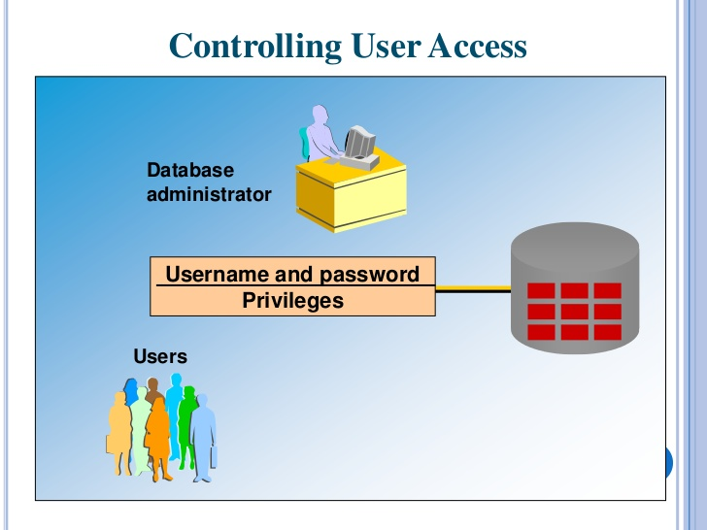

* **Administrators**− Administrators maintain the DBMS and are responsible for administrating the database. They are responsible to look after its usage and by whom it should be used. They create access profiles for users and apply limitations to maintain isolation and force security. Administrators also look after DBMS resources like system license, required tools, and other software and hardware related maintenance.

* **Designers**− Designers are the group of people who actually work on the designing part of the database. They keep a close watch on what data should be kept and in what format. They identify and design the whole set of entities, relations, constraints, and views.

* **End Users**− End users are those who actually reap the benefits of having a DBMS. End users can range from simple viewers who pay attention to the logs or market rates to sophisticated users such as business analysts.

**Entity-Relationship Model**

Entity-Relationship (ER) Model is based on the notion of real-world entities and relationships among them. While formulating real-world scenario into the database model, the ER Model creates entity set, relationship set, general attributes and constraints.

ER Model is best used for the conceptual design of a database.

ER Model is based on −

* **Entities**and their
* **Relationships**among entities.

These concepts are explained below.

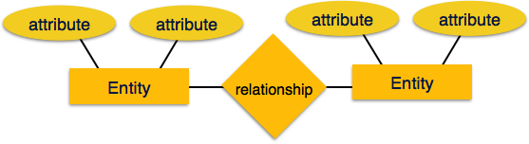

* **Entity**− An entity in an ER Model is a real-world entity having properties called **attributes**. Every **attribute** is defined by its set of values called **domain**. For example, in a school database, a student is considered as an entity. Student has various attributes like name, age, class, etc.
* **Relationship**− The logical association among entities is called **relationship**. Relationships are mapped with entities in various ways. Mapping cardinalities define the number of association between two entities.

Mapping cardinalities −

* + one to one
  + one to many
  + many to one
  + many to many

Relational Model

The most popular data model in DBMS is the Relational Model. It is more scientific a model than others. This model is based on first-order predicate logic and defines a table as an **n-ary relation**.

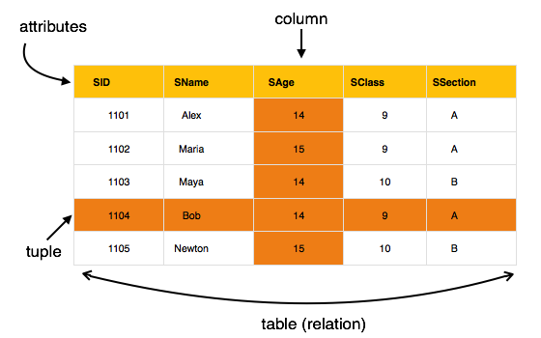

The main highlights of this model are −

* Data is stored in tables called **relations**.
* Relations can be normalized.
* In normalized relations, values saved are atomic values.
* Each row in a relation contains a unique value.
* Each column in a relation contains values from a same domain.

**Database Schema**

A database schema is the skeleton structure that represents the logical view of the entire database. It defines how the data is organized and how the relations among them are associated. It formulates all the constraints that are to be applied on the data.

A database schema defines its entities and the relationship among them. It contains a descriptive detail of the database, which can be depicted by means of schema diagrams. It’s the database designers who design the schema to help programmers understand the database and make it useful.

A database schema can be divided broadly into two categories −

* **Physical Database Schema**− This schema pertains to the actual storage of data and its form of storage like files, indices, etc. It defines how the data will be stored in a secondary storage.
* **Logical Database Schema**− This schema defines all the logical constraints that need to be applied on the data stored. It defines tables, views, and integrity constraints.

**Database Instance**

It is important that we distinguish these two terms individually. Database schema is the skeleton of database. It is designed when the database doesn't exist at all. Once the database is operational, it is very difficult to make any changes to it. A database schema does not contain any data or information.

A database instance is a state of operational database with data at any given time. It contains a snapshot of the database. Database instances tend to change with time. A DBMS ensures that its every instance (state) is in a valid state, by diligently following all the validations, constraints, and conditions that the database designers have imposed.

If a database system is not multi-layered, then it becomes difficult to make any changes in the database system. Database systems are designed in multi-layers as we learnt earlier.

**Data Independence**

A database system normally contains a lot of data in addition to users’ data. For example, it stores data about data, known as metadata, to locate and retrieve data easily. It is rather difficult to modify or update a set of metadata once it is stored in the database. But as a DBMS expands, it needs to change over time to satisfy the requirements of the users. If the entire data is dependent, it would become a tedious and highly complex job.

**ER Model - Basic Concepts**

The ER model defines the conceptual view of a database. It works around real-world entities and the associations among them. At view level, the ER model is considered a good option for designing databases.

**Entity**

An entity can be a real-world object, either animate or inanimate, that can be easily identifiable. For example, in a school database, students, teachers, classes, and courses offered can be considered as entities. All these entities have some attributes or properties that give them their identity.

An entity set is a collection of similar types of entities. An entity set may contain entities with attribute sharing similar values. For example, a Students set may contain all the students of a school; likewise a Teachers set may contain all the teachers of a school from all faculties. Entity sets need not be disjoint.

**Attributes**

Entities are represented by means of their properties, called **attributes**. All attributes have values. For example, a student entity may have name, class, and age as attributes.

There exists a domain or range of values that can be assigned to attributes. For example, a student's name cannot be a numeric value. It has to be alphabetic. A student's age cannot be negative, etc.

**Types of Attributes**

* + **Simple attribute**− Simple attributes are atomic values, which cannot be divided further. For example, a student's phone number is an atomic value of 10 digits.
  + **Composite attribute**− Composite attributes are made of more than one simple attribute. For example, a student's complete name may have first\_name and last\_name.
  + **Derived attribute**− Derived attributes are the attributes that do not exist in the physical database, but their values are derived from other attributes present in the database. For example, average\_salary in a department should not be saved directly in the database, instead it can be derived. For another example, age can be derived from data\_of\_birth.
  + **Single-value attribute**− Single-value attributes contain single value. For example − Social\_Security\_Number.
  + **Multi-value attribute**− Multi-value attributes may contain more than one values. For example, a person can have more than one phone number, email\_address, etc.

These attribute types can come together in a way like −

* + simple single-valued attributes
  + simple multi-valued attributes
  + composite single-valued attributes
  + composite multi-valued attributes

**Entity-Set and Keys**

Key is an attribute or collection of attributes that uniquely identifies an entity among entity set.

For example, the roll\_number of a student makes him/her identifiable among students.

* + **Super Key**− A set of attributes (one or more) that collectively identifies an entity in an entity set.
  + **Candidate Key**− A minimal super key is called a candidate key. An entity set may have more than one candidate key.
  + **Primary Key**− A primary key is one of the candidate keys chosen by the database designer to uniquely identify the entity set.

**Relationship**

The association among entities is called a relationship. For example, an employee **works\_at** a department, a student **enrolls** in a course. Here, Works\_at and Enrolls are called relationships.

Relationship Set

A set of relationships of similar type is called a relationship set. Like entities, a relationship too can have attributes. These attributes are called **descriptive attributes**.

**Degree of Relationship**

The number of participating entities in a relationship defines the degree of the relationship.

* + Binary = degree 2
  + Ternary = degree 3
  + n-ary = degree

**Mapping Cardinalities**

**Cardinality** defines the number of entities in one entity set, which can be associated with the number of entities of other set via relationship set.

* + - **One-to-one**− One entity from entity set A can be associated with at most one entity of entity set B and vice versa.
    - **One-to-many**− One entity from entity set A can be associated with more than one entities of entity set B however an entity from entity set B, can be associated with at most one entity.
    - **Many-to-one**− More than one entities from entity set A can be associated with at most one entity of entity set B, however an entity from entity set B can be associated with more than one entity from entity set A.
    - **Many-to-many**− One entity from A can be associated with more than one entity from B and vice versa.

**Question 1**

**0 / 1 pts**

It is based on the star or distributed star topology, but it has a topology and protocol of its own.



Token Ring

**You Answered**



Ring Network Topology

**Correct Answer**



ARCNET



Ethernet

**Question 2**

**1 / 1 pts**

One of the most widely used network protocol. It makes use of the linear bus topology.



Token Ring



ARCNET

**Correct!**



Ethernet



Ring Network Topology

**Question 3**

**1 / 1 pts**

Refers to the computers that are relatively near each other and connected by wires or wireless link.

**Correct!**



LAN (Local Area Network)



Wireless Communication



WIFI



WAN (Wide Area Network)

**Question 4**

**1 / 1 pts**

The task of linking the source and destination.



Source

**Correct!**



Handshaking



Destination



Front-end-processor

**Question 5**

**1 / 1 pts**

It uses radio frequencies (RF) or infrared (IR) waves to transmit data between devices on a LAN.

**Correct!**



Wireless Communication



WIFI



LAN (Local Area Network)



WAN (Wide Area Network)

**Question 6**

**1 / 1 pts**

Commonly known as “Coax” , is widely used in cable TV.



STP



Fiber Optic cable



UTP

**Correct!**



Coaxial cable

**Question 7**

**1 / 1 pts**

Combines the techniques of shielding, cancellation, and wire twisting. Each pair of wires is wrapped in a metallic foil.



Coaxial cable

**Correct!**



Shielded Twisted–Pair (STP) Cable



Fiber Optic cable



Unshielded Twisted–Pair (UTP) Cable

**Question 8**

**1 / 1 pts**

A collection of computers which are connected to one another.



Wireless communication



Network media

**Correct!**



Computer network



Computer security

**Question 9**

**1 / 1 pts**

Each terminal is connected to exactly **two nodes**, giving the network a circular shape.



Star Topology



Mesh Topology

**Correct!**



Ring topology



Bus Topology

**Question 10**

**1 / 1 pts**

A host is connected to one or multiple hosts.



Bus Topology



Tree Topology

**Correct!**



Mesh Topology



Star Topology

**Question 11**

**1 / 1 pts**

A network structure whose design contains more than one topology.



Ring Topology



Mesh Topology

**Correct!**



Hybrid Network Topology



Bus Topology

**Question 12**

**1 / 1 pts**

A modem can transfer data in only one direction.

**Correct!**



Simplex



Half duplex



Full duplex



Modem

**Question 13**

**1 / 1 pts**

A  modem has the capacity to transfer data in both the directions but only one at a time.



Full duplex

**Correct!**



Half duplex



Modem



Simplex

**Question 14**

**1 / 1 pts**

It also known as **network interface card (NIC).**

**Correct!**



Ethernet Card



Routing Table



Router



RJ45 Connector

**Question 15**

**1 / 1 pts**

A **network layer** hardware device that transmits data from one LAN to another if both networks support the same set of protocols.



Routing Table



Ethernet Card

**Correct!**



Router



RJ45 Connector

**Question 16**

**1 / 1 pts**

A network device that connects other devices to **Ethernet** networks through **twisted pair** cables.



Wi-Fi Card



Gateway



Router

**Correct!**



Switch

**Question 17**

**1 / 1 pts**

A network device used to connect two or more dissimilar networks.

**Correct!**



Gateway



RJ45 Connector



Ethernet Card



Switch

**Question 18**

**1 / 1 pts**

A **card** used to connect any device to the local network wirelessly.



Gateway



Switch



Router

**Correct!**



Wi-Fi Card

**Question 19**

**1 / 1 pts**

 It converts digital data into analog data when the data is being sent by the computer.



modem



demodulator

**Correct!**



modulator



simplex

**Question 20**

**1 / 1 pts**

It converts analog data signals into digital data when it is being received by the computer.



modulator



modem



Simplex

**Correct!**



demodulator

**Question 21**

**1 / 1 pts**

An 8-pin jack used by devices to physically connect to **Ethernet** based **local area networks (LANs)**.



Ethernet Card



Router



No answer text provided.

**Correct!**



RJ45 Connector

**Question 22**

**1 / 1 pts**

 E-Commerce enables the use of credit cards, debit cards, smart cards, electronic fund transfer via bank's website, and other modes of electronics payment.



Advertising / Marketing

**Correct!**



Non-Cash Payment



24x7 Service availability



Inventory Management

**Question 23**

**1 / 1 pts**

A collection of related data and data is a collection of facts and figures that can be processed to produce information.



E-Commerce



Internet



Networking

**Correct!**



Database

**Question 24**

**1 / 1 pts**

A methodology of modern business, which addresses the need of business organizations, vendors and customers to reduce cost and improve the quality of goods and services while increasing the speed of delivery.



Networking



Internet

**Correct!**



E-Commerce



Database

**Question 25**

**0 / 1 pts**

A telecommunications network that allows computers to exchange data.



Modem

**You Answered**



Data communications



Network Devices

**Correct Answer**



Computer Network

**Question 26**

**1 / 1 pts**

It is based on the notion of real-world entities and relationships among them.



Database Schema



Database Instance



Data Independence

**Correct!**



Entity-Relationship Model

**Question 27**

**1 / 1 pts**

The following are are advantages of using bus topology , except :



Can be extended easily



Easy to install and maintain



Very reliable because of single transmission line

**Correct!**



Troubleshooting is difficult as there is no single point of control

**Question 28**

**1 / 1 pts**

A collection of computers which are connected to one another.



LAN (Local Area Network)



Network Media

**Correct!**



Computer Network



Data communications

**Question 29**

**1 / 1 pts**

A wired network spread over a single site like an office, building or manufacturing unit.



Wide Area Network



Personal Area Network

**Correct!**



LAN or Local Area Network



Metropolitan Area Network.

**Question 30**

**1 / 1 pts**

The interconnection between devices within the range of a person’s private space, typically within a range of 10 metres.



Metropolitan Area Network

**Correct!**



Personal Area Network



Local Area Network



Wide Area Network

**Question 31**

**1 / 1 pts**

A network that spread over a country or many countries.



Local Area Network



Metropolitan Area Network

**Correct!**



Wide Area Network



Personal Area Network

**Question 32**

**1 / 1 pts**

 A network spread over a city, college campus or a small region.



Personal Area Network



Local Area Network

**Correct!**



Metropolitan Area Network



Wide Area Network

**Question 33**

**0 / 1 pts**

It is used for a specialized task of serving the needs of each node.

**Correct Answer**



Server



Modem



Internet

**You Answered**



Client

**Question 34**

**1 / 1 pts**

A type of cabling that is used for telephone communications and most modern Ethernet networks.



Coaxial Cable



Fiber – Optic Cable

**Correct!**



Twisted – Pair Cable



Wireless Communications

**Question 35**

**1 / 1 pts**

A cable that transmits pulsating *beams of light*.



Twisted – Pair Cable

**Correct!**



Fiber – Optic Cable



Coaxial Cable



Wireless Communications

**Question 36**

**1 / 1 pts**

These are some of the advantages of radio wave transmissions, except:



Installation and maintenance of devices is cheap



No land needs to be acquired for laying cables

**Correct!**



Insecure communication medium



Inexpensive mode of information exchange

**Question 37**

**1 / 1 pts**

It permits the communications satellite to maintain a fixed position relative to the surface of the earth.



Data Communication



Radio Wave



Microwave radio signals

**Correct!**



Geosynchronous orbit

**Question 38**

**1 / 1 pts**

A transmission of data using radio frequencies.



Geosynchronous orbit



Computer Network



Data Communication

**Correct!**



Radio Wave

**Question 39**

**1 / 1 pts**

 It defined as an Information super Highway, to access information over the web.



Extranet

**Correct!**



Internet



Intranet



Domain Name System

**Question 40**

**0 / 1 pts**

 It refers to network within an organization, using internet to connect to the outsiders in controlled manner.

**You Answered**



Domain Name System



Internet



Uniform Resource Locator (URL)

**Correct Answer**



Extranet

**Question 41**

**1 / 1 pts**

It refers to a web address which uniquely identifies a document over the internet.



IP Address



Internet Service Providers (ISP)

**Correct!**



Uniform Resource Locator (URL)



Domain Name Space

**Question 42**

**1 / 1 pts**

A method of communicating by two-way video and audio transmission with help of telecommunication technologies.



Gopher



World Wide Web (WWW)

**Correct!**



Video Conferencing



File Transfer Protocol (FTP)

**Question 43**

**1 / 1 pts**

A company offering access to internet.

**Correct!**



Internet Service Provider (ISP)



Dial-up Connection



ISDN



DSL

**Question 44**

**1 / 1 pts**

It is a form of broadband connection as it provides connection over ordinary telephone lines.

**Correct!**



Digital Subscriber Line



Integrated Services Digital Network



Dial-up



DNS

**Question 45**

**1 / 1 pts**

It connection uses telephone line to connect PC to the internet.

**Correct!**



Dial-up



Internet Service Providers (ISP)



Integrated Services Digital Network



Digital Subscriber Line

**Question 46**

**0 / 1 pts**

It is designed explicitly as addressing protocol.



File Transfer Protocol (FTP)

**Correct Answer**



Internet Protocol (IP)

**You Answered**



Transmission Control Protocol (TCP)



User Datagram Protocol (UDP)

**Question 47**

**1 / 1 pts**

A substitute communication protocol to Transmission Control Protocol implemented primarily for creating loss-tolerating and low-latency linking between different applications.



Trivial File Transfer Protocol (TFTP)



File Transfer Protocol (FTP)



Internet Protocol (IP)

**Correct!**



User Datagram Protocol (UDP)

**Question 48**

**1 / 1 pts**

 It is also used to transfer the files but it transfers the files without authentication

**Correct!**



Trivial File Transfer Protocol (TFTP)



File Transfer Protocol (FTP)



User Datagram Protocol (UDP)



Internet Protocol (IP)

**Question 49**

**0 / 1 pts**

A business model sells its products to an intermediate buyer who then sells the product to the final customer.



Consumer - to - Consumer

**Correct Answer**



Business - to - Business



Consumer - to - Business

**You Answered**



Business - to - Consumer

**Question 50**

**1 / 1 pts**

A business model helps consumers to sell their assets like residential property, cars, motorcycles, etc., or rent a room by publishing their information on the website.



Consumer - to - Business

**Correct!**



Consumer - to - Consumer



Government - to - Business



Business - to - Government